Town of Dunkirk

Comprehensive Plan

August 2024 DRAFT

Prepared by Dane County Planning & Development

ELEMENT 1: ISSUES & OPPORTUNITIES

Chapter 1: Introduction 6

I. Town Profile 6

II. Planning History 6

III. Plan Updates 6

Chapter 2: Background & Existing Conditions 7

I. Population Trends and Projections 7

II. Housing and Household Trends 10

III. Labor and Employment Trends 10

IV. Key Planning Issues and Goals 11

Chapter 3: Existing Housing Conditions 13

I. Housing Stock Characteristics 13

II. Projected Need for Housing 15

III. Programs 15

Chapter 4: Goals, Objectives, & Policies 16

Chapter 5: Existing Transportation Network 19

I. Roadways 19

II. Transit 19

III. Taxis and Ride Hail Services 19

IV. Carpool and Vanpool Services 19

V. Specialized Transportation Services 19

VI. Bicycles and Pedestrians 20

VII. Rail 20

VIII. Intercity Bus Service 20

IX. Trucking 20

X. Water Transportation 21

XI. Airports 21

XII. Snowmobile Trails 21

Chapter 6: Transportation Plans & Programs 21

Chapter 7: Goals, Objectives, & Policies 22

Chapter 8: Existing Infrastructure & Services 24

I. Town Hall 24

II. Water Supply 24

III. On-Site Wastewater Treatment 24

IV. Solid Waste Disposal and Recycling Facilities 24

V. Stormwater Management 24

VI. Law Enforcement 24

VII. Fire Protection and Emergency Medical Service (EMS) 24

VIII. Cemeteries 24

IX. Libraries 24

X. Schools 25

XI. Parks and Recreational Facilities 25

XII. Health Care Facilities 25

XIII. Child Care Facilities 25

XIV. Faith Based Facilities 25

XV. Senior Services 25

XVI. Other Community Services 25

XVII. Telecommunications Facilities 26

XVIII. Broadband 26

XIX. Power Plants and Transmission 26

Chapter 9: Service Demand Forecast 26

Chapter 10: Goals, Objectives, & Policies 26

Chapter 11: Agricultural Resource Inventory 29

I. Historic Trends 29

II. Existing Farming 30

III. Agricultural Property Size and Scale 31

IV. Future Prospects 32

Chapter 12: Natural Resources Inventory 32

I. Environmentally Sensitive Areas 32

II. Soils 32

III. Wetlands 32

IV. Groundwater 33

V. Wildlife and Endangered Species 33

VI. Woodlands 33

VII. Mineral Resources 33

Chapter 13: Cultural Resources Inventory 33

I. Historic Sites 33

II. Archaeological Sites 34

III. Community Design 35

Chapter 14: Goals, Objectives, & Policies 35

I. Agricultural Resources 35

II. Mineral Resources 36

III. Natural Resource 37

IV. Cultural Resources 38

Chapter 15: Economic Base 41

I. Labor and Income 41

II. Major Industries and Employment 43

III. Environmentally Contaminated Sites 43

Chapter 16: Desired Economic Development 44

IV. Resident Survey Results 44

V. Strengths and Weaknesses for Economic Development 44

VI. Economic Development Programs 44

Chapter 17: Goals, Objectives, & Policies 45

Chapter 18: Intergovernmental Cooperation 48

I. Regional Context 48

II. Existing or Potential Conflicts with Neighboring Jurisdictions 49

Chapter 19: Goals, Objectives, & Policies 49

Chapter 20: Existing Land Uses 51

I. Agriculture 51

II. Woodlands 51

III. Residential 51

IV. Commercial 51

V. Other Public Uses 51

Chapter 21: Future Land Use 53

I. Historic Demand 53

II. Land Use Projections 53

III. Land Use Conflicts 53

IV. Redevelopment Opportunities 54

Chapter 22: Goals, Objectives, & Policies 54

I. Land Use Guidance 54

II. Land Use District Regulations 56

Chapter 23: Regulatory Tools 65

I. Town of Dunkirk Driveway Ordinance 65

II. Town of Dunkirk Building Permit Ordinance 65

III. Zoning Ordinance- Chapter 10, Dane County Code 65

IV. Land Division Ordinance- Chapter 75, Dane County Code 65

V. Erosion Control and Stormwater Management Ordinance- Chapter 14, Dane County Code 65

VI. Shoreland Zoning Ordinance- Chapter 11, Dane County Code 65

VII. Floodplain Zoning Ordinance- Chapter 17, Dane County Code 65

VIII. Sign Regulations 66

IX. Building and Mechanical Codes 66

X. Rural Density Policy 66

XI. Sanitary Codes 66

Chapter 24: Adoption, Evaluation, Amendments & Updates 66

Chapter 25: Implementation Timeline 67

element 1:  
issues & opportunities

INSERT PICTURE

# Introduction

## Town Profile

The Town of Dunkirk, located in southeastern Dane County, is bounded by the Towns of Albion, Rutland, and Pleasant Springs and by the Rock County Town of Porter. The major transportation link in the town is U.S. Highway 51 connecting Madison and Janesville. At the [2020 census](https://data.census.gov/profile/Dunkirk_town,_Dane_County,_Wisconsin?g=060XX00US5502521100#populations-and-people), 1,881people lived in Dunkirk.

|  |  |
| --- | --- |
| **Vision: [insert vision statement]** | |
| **20,084 acres** | **25 new people in 13 homes by 2040** |
| **750 people** | **50.5 average age** |
| **340 households** | **6.5% minority** |
| **$93,958 median household annual income** | **> 12% worked in agriculture, forestry, fishing, hunting, or mining** |

Dunkirk is characterized by flat to rolling countryside. The Yahara River bisects the Town from North to South and several streams, many of which flow into the Yahara River, have broad floodplains. Dunkirk is a rural community featuring abundant prime farmland, as classified by the U.S. Department of Agriculture. Therefore, farming is the primary land use and occupation.

The City of Stoughton, located to the northwest, provides commercial and community services as well as nonfarm employment opportunities to town residents.

## Planning History

The Town adopted the first and existing *Town of Dunkirk Comprehensive Plan* in 2006, in compliance with the state’s Comprehensive Planning Law (Sec 66.1001). The Dane County Board of Supervisors adopted the town plan as part of the *Dane County Comprehensive Plan.* With assistance from Dane County Planning and Development, the Town gathered public input and crafted the goals, objectives, and policies contained in this plan to guide growth and development over the next twenty years and reflect this in a Land Use Plan.

## Plan Updates

As per Wisconsin’s comprehensive planning legislation, the Town will review and update the *Comprehensive Plan* at least every ten years. Changing conditions and goals in the Town will be noted and adjustments will be made to the *Comprehensive Plan* text and maps accordingly. This plan update is intended to aid the Plan Commission and Board in meeting statutory timeline requirements and achieve the Town’s goals.

# Background & Existing Conditions

## Population Trends and Projections

From 1990-2000, the population growth rate was near record levels. Mostly due to immigration. Since then, however, Dunkirk has experienced population losses. In 1990, 2,121 people resided in Dunkirk, and in 2000, 2,053 people lived there. In 2020, the population dropped further to 1,881. Despite these historic trends, pressure for housing across the region may reverse this trend (note: this trend is in part due to annexation of populated areas), the WI Department of Administration (WIDOA) projects an average annual negative growth rate of less than 1% over the next 20 years, losing 100 people by 2040.

Figure 1: Population 1970-2020 and Projections to 2040

Source: Applied Population Lab- Wisconsin Population and housing Estimates-

Table 1: Population Projections of Area

|  |  |  |  |  |  |
| --- | --- | --- | --- | --- | --- |
| **Municipality** | **2020 Census** | **2025** | **2030** | **2035** | **2040** |
| **T. Dunkirk** | 1,881 | 1,895 | 1,870 | 1,830 | 1,780 |
| T. Albion | 2,069 | 1,975 | 1,980 | 1,960 | 1,935 |
| T. Rutland | 1,977 | 2,125 | 2,175 | 2,200 | 2,220 |
| T. Pleasant Springs | 3,078 | 3,345 | 3,400 | 3,425 | 3,435 |
| T. Dunn | 4,880 | 4,825 | 4,765 | 4,655 | 4,525 |

Source: Wisconsin Department of Administration

### A. Age

The median age increased from about 45 years in 2010 to 50 years in 2020. In comparison, the median age in Dane County increased from 34.3 to 35.2 years of age. The difference from 2010 to 2020 is primarily due to an increase in groups 55 years old and older. In comparison with the County, the Town showed fewer people aged 20-45 years in the 1990 and 2020 censuses, with the largest age brackets being 55-59 (mostly male) and 75-79 years (mostly female), and followed by 35-39 (mostly female), and less than 5 years old. The Town of Dunkirk is likely to see an increasing proportion the 65+ population.

Figure 2: Age Pyramids

### B. Ethnic Minorities

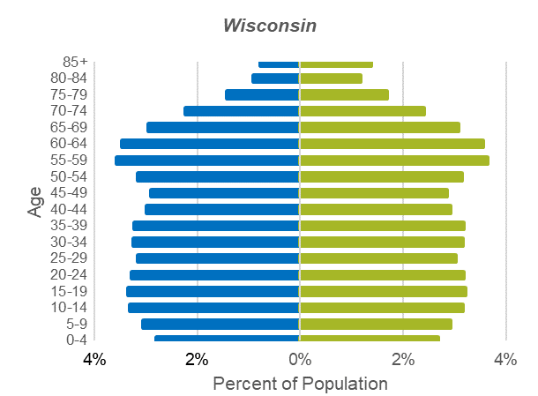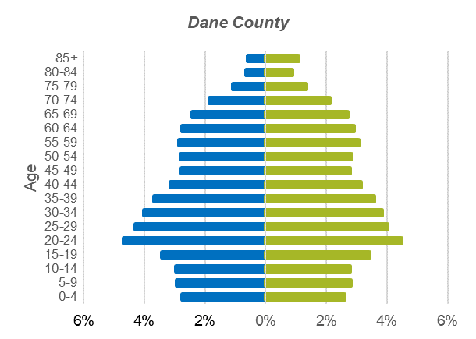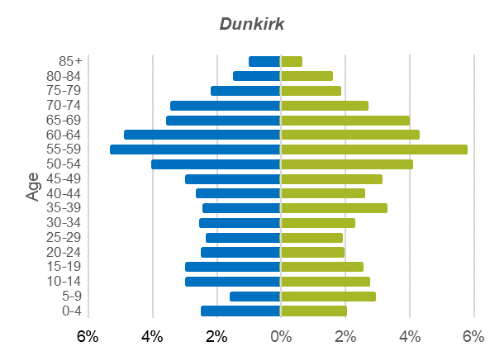

U.S. Census data show that the minority population of the Town of Dunkirk is less than 6% of the total population. Minority populations include Asian, Black/African American and American Indian/ Alaskan Native (each less than 1%).

### C. Education

According to the [American Community Survey](https://data.census.gov/profile/Dunkirk_town,_Dane_County,_Wisconsin?g=060XX00US5502521100#education), 36% of residents had a bachelor’s degree or higher in 2022, lower than the 56% of Dane County residents. Nearly 12% of people hold an associate’s degree, 21% went to some college, and 30% attained a high school or equivalent degree.

### D. Income

Based on 2022 American Community Survey 5-year estimates, the median household annual income was approximately $90,833, slightly higher than the Dane County median of $84,831. Dunkirk had a lower poverty rate, less than 5%, across all age groups, than Dane County, 10%, and Wisconsin.

Source: U.S. Census Bureau, ACS 5-year estimates 2010, 2020

Figure 3: Population by Race & Ethnicity

Source: U.S. Census Bureau, Demographic Profile 2020

Figure 4: Household Median Income (2019 adjusted dollars)

Source: U.S. Census Bureau, ACS 5-year estimates 2017-2021

Figure 5: Income Distribution (2019 Adjusted Dollars)

Source: U.S. Census Bureau, ACS 5-year estimates 2017-2021

Figure 6: Poverty Rates by Age

Source: U.S. Census Bureau, ACS 5-year estimates 2017-2021

## Housing and Household Trends

The number of housing units in the Town decreased from 802 in 2010 to 778 in 2020, a 3% decrease. Mean household occupancy fell from 2.62 persons in 2010 to 2.47 persons in 2020. This change mirrors a national trend in decreasing household size. Based on WIDOA projections, there will be 60 fewer households by 2040.

## Labor and Employment Trends

The Town of Dunkirk’s labor force includes individuals 16 years old who are currently employed or who are available for work. Between 2017 and 2021, Dunkirk enjoyed a lower unemployment rate (1.1%) than both Dane County (2.4%) and Wisconsin (3.5%).

Dunkirk’s working population is primarily employed in educational services, and health care and social assistance (22%) and government (18%). The average worker commutes alone and drives an average of 25 minutes to work *(*[*American Community Survey, 2022*](https://data.census.gov/profile/Dunkirk_town,_Dane_County,_Wisconsin?g=060XX00US5502521100#employment)*).*

Figure 7: Unemployment Rate (16 years old and older)

Source: U.S. Census Bureau, ACS 5-year estimates 2017-2021

Figure 8: Employment by Industry (16+ years old)

Source: U.S. Census Bureau, ACS 5-year estimates 2022 5-year estimates

## Key Planning Issues and Goals

### Public Participation

At the beginning of the planning process, the town appointed a comprehensive planning committee to oversee the development of this comprehensive plan update. The committee identified various methods of ensuring input, including a community survey, website and newsletter updates, a consistent schedule of monthly meetings, and at least one public hearing preceding adoption. The survey generated useful input into the comprehensive planning effort. [Insert number] residents responded to the survey. Results indicated _____________:

* [Insert results in bulleted format]

A detailed analysis of survey results is in Appendix 1.

### B. Goals

* [Insert results in bulleted format]

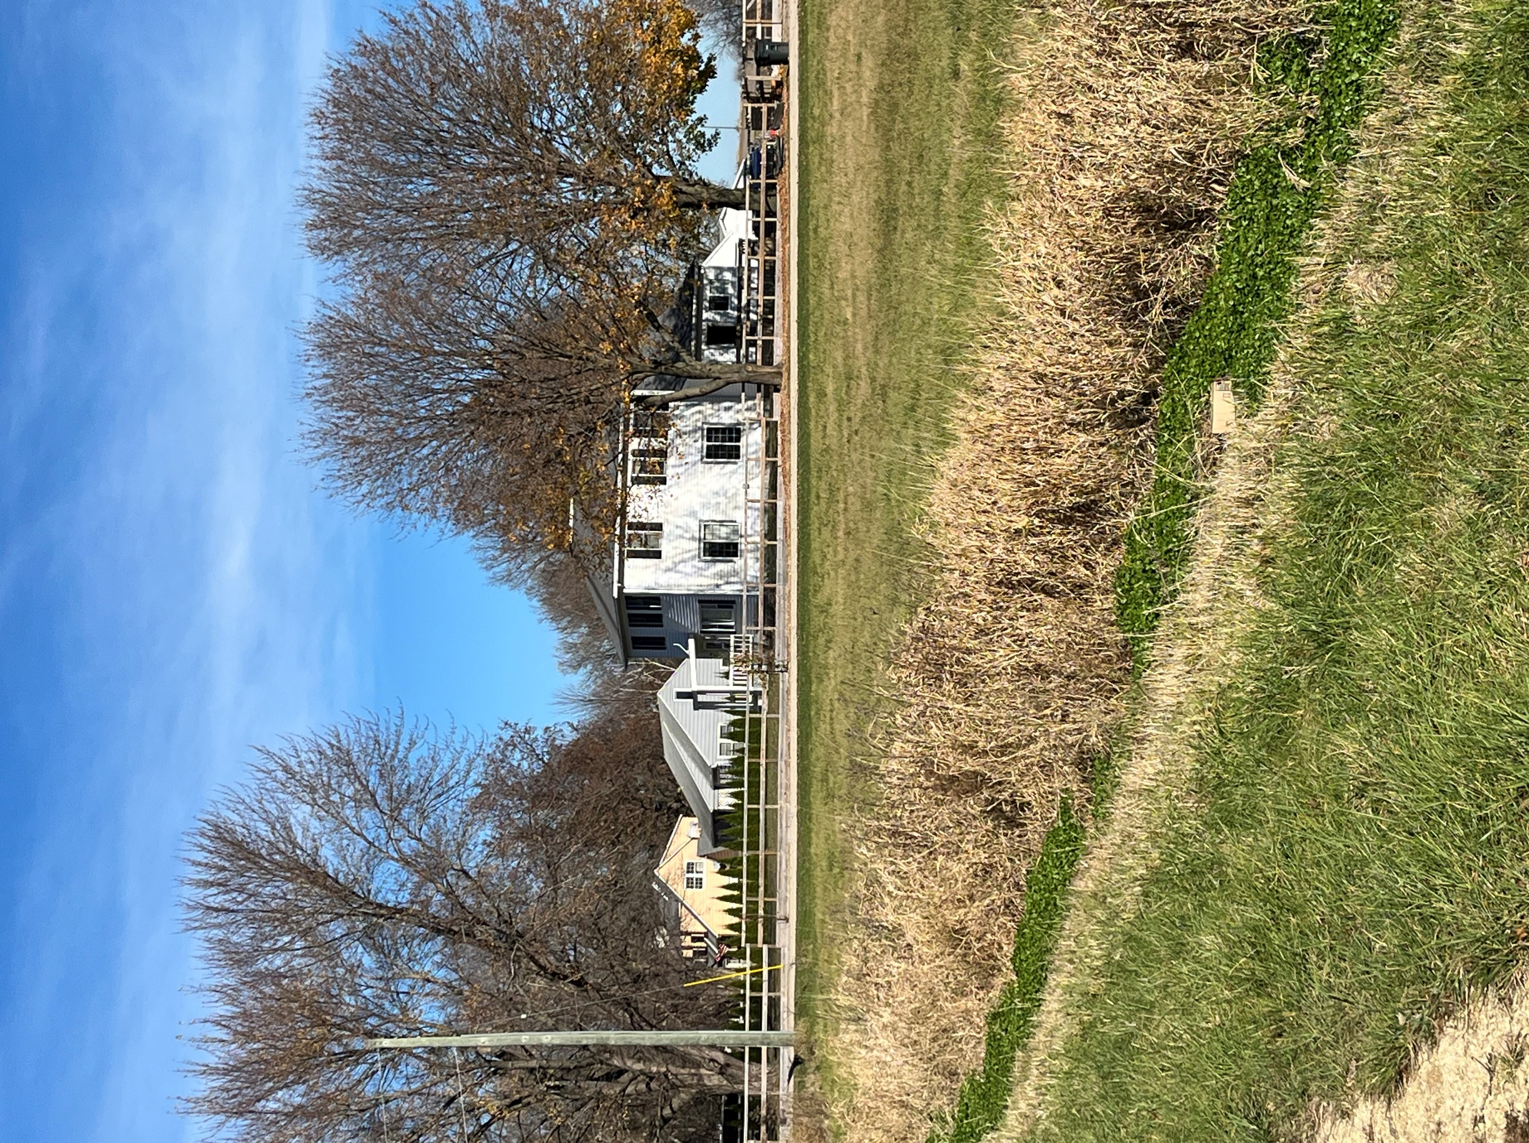element 2:  
Housing

# Existing Housing Conditions

## Housing Stock Characteristics

The number of housing units in the town increased slightly from 776 to 800 between 2000 and 2020. This is less than the 25% increase for Dane County over the same time period. Housing in concentrated along the Yahara River and in the Hannerville hamlet.

Of the occupied homes, detached, single-family residences make up 96% of the housing units in the Town of Dunkirk. As of the 2020 Dane County Land Use Inventory, there were 678 detached single-family residences and 20 multi-family homes in the town. According to the 2021 American Community Survey, 50% of the houses were built between 1960 and 1989 and about 30% were built prior to 1940.

Figure 9: Number of Housing Units 2000-2020

Source: U.S. Bureau of the Census: 2000, 2010, 2020 Decennial Census

Figure 10: Age of Housing Stock

Source: American Community Survey, 2020

### A. Occupancy

In 2022, in Dunkirk, it was estimated that 89% of the homes were owner-occupied, showcasing a prevalence of property ownership.

Figure 11: Owner-Occupied Housing

Source: U.S. Census Bureau, ACS 5-year estimates 2018-2022

About 20 homes were vacant in 2020. The estimated vacancy rate in 2022 was 0%. According to the U.S. Department of Housing and Urban Development (HUD), a healthy owner-occupied vacancy rate is around 2% because it allows residents housing options.

### B. Value

In 2022, the median value of owner-occupied homes in the Town of Dunkirk was estimated at $294,500, 22% lower than the median value for Dane County.

Figure 12: Median Housing Value

Source: U.S. Census Bureau, ACS 5-year estimates 2018-2022

### C. Affordability

“Cost-burdened” is defined as homeowners and renters who spend more than 30% of their monthly income on housing costs. Compared with Dane County and Wisconsin, the Town has a smaller percentage of cost-burdened residents, except mortgage holders are slightly more burdened in the town then the County or State as a whole.

Figure 13: Cost Burdened Households

Source: U.S. Census Bureau, ACS 5-year estimates 2018-2022

## Projected Need for Housing

Based on WI Department of Administration projections and 2020 Census data, the County projects 1,780 people by 2040 in the Town. With the mean household size in 2020 at 2.47 persons, this suggests the town will lose the need for 40 homes by 2040.

## Programs

1. [Rural Development- USDA](https://www.rd.usda.gov/programs-services) is a federal program that provides housing and community development programs for rural areas. The program provides support for rental housing development, direct and guaranteed mortgage loans for home buyers, and support for self-help and cooperative housing development.
2. 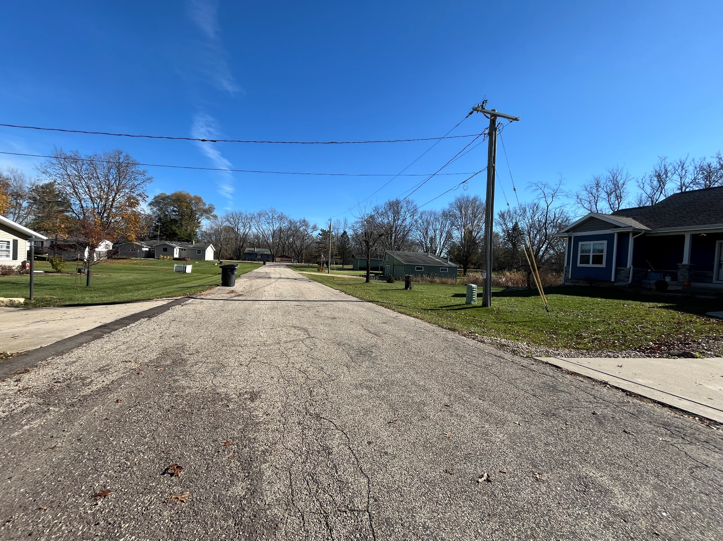[Wisconsin Housing and Economic Development Authority (WHEDA)](https://www.wheda.com/Home-Buyers/Getting-Started/) provides first-time homebuyers financing, home repair grants, and financing for multifamily housing. Specific programs change with the needs and demands of the housing market.
3. Community Development Block Grant (CDBG) program provides annual grants on a formula basis to entitled cities and counties to provide decent housing and a suitable living environment, and expand economic opportunities, principally for low- and moderate-income persons. The funds that Dane County receives from HUD are available to local recipients including municipalities (outside of Madison), non-profit, and for-profit entities.
4. [Home Investment Partnerships (HOME) programs](https://cdbg.countyofdane.com/programs/cdbg/about) provides grants to States and localities that communities use, often in partnership with local nonprofit groups, to fund a wide range of activities that build, buy, and/or rehabilitate affordable housing or provide direct rental assistance to low-income people.

# Goals, Objectives, & Policies

### Goals

1. Feature a variety of housing opportunities consistent with a rural setting.

### B. Objectives

1. Permit new housing types, predominantly single-family, to meet projected demand.
2. Encourage upkeep of existing housing stock.
3. Support independent and assisted living facilities for special populations (elderly, developmentally disabled, etc.).
4. Maintain a quiet nature in neighborhoods.
5. Minimize the agricultural and open space lands consumed by new residential development.
6. Provide adequate public infrastructure, services, and developable land to meet existing and future housing demand.

### Policies

* + - 1. Support and educate residents about home rehabilitation and affordability programs.
      2. Follow town density policy as outlined in the Land Use Goals, Objectives, and Policies (see Element 8: Land Use) to ensure residential development includes a range of lot sizes, dwelling types, densities, and prices.
      3. Residential density limited to one residence per 40 acres of farm unit owned as of the determination date of July 1, 1979.
      4. Any existing residence (non-farm residence, farm residence, etc.) located on a parcel of any size, regardless when residence was constructed, shall be counted as one residential split.
      5. Support conservation or cluster housing development.
      6. Allow single-family homes conversion into duplex units in some single-family residential areas.
      7. Encourage green building technologies and practices be used in designing, constructing, and maintaining homes and accessory buildings.
      8. Prevent the incursion of incompatible non-residential land uses into residential neighborhoods.
      9. Redirect high-density development requiring public transportation, sewer, or water to an Urban Service Area.
      10. Limit rezoning for new non-farm residential development to the acreage that is need for the residential or hobby use proposed.
      11. Nonfarm, residential development requiring rezones or land divisions is subject to the following:

1. Minimum lot size is one-acre.
2. Rezoning limited to the acreage that is necessary for the residential or hobby use contemplated.
3. No access lanes or driveways shall be permitted to cross agricultural land to reach non-farm development without Town Plan Commission and Town Board approval. To be approved, new access lanes and driveways, or existing access lanes being converted to driveways, and any attendant buildings must:
4. Not cross part of any field so as to make cropping the field more difficult.
5. Be located away from existing agricultural operations and near a public road whenever possible to minimize potential conflicts with agricultural operations.
6. Be located discreetly to blend in with the rural landscape and not visually prominent in a manner that undermines Dunkirk’s rural character.
7. Be accessible to fire, police, ambulance vehicles and personnel to service health and public safety needs.
8. Be located so as to minimize disturbing or destroying woodland areas, wetland, wildlife habitats, prairies, hilltops, or ridgelines.
9. Access lanes or driveways longer than 150 feet must be located where the smallest possible area of soils classified as prime farmland or farmland of statewide importance, whether actively farmed or not, are used. The lengths of existing access lanes or driveways servicing farms and residences may be used as guidance to determine appropriate length.
   * + 1. Farmland may be split from the farm residence and buildings provided no further development takes place on the farmland, but existing farmsteads with agricultural buildings must maintain sufficient land for an agricultural or hobby farm use. This would not be counted as a split.
       2. Enable landowners to participate in a transfer of development rights (TDR) program (See Element 8: Land Use).
       3. Farm residences proposed under Dane County Zoning Ordinance (Farm Plan) 10.123(2) sub (b) and (c) undergo town advisory review. Farm residences proposed in the A-1EX district under this provision shall be considered by the town only if the following criteria are met:
          1. Proposal abides by the density policy of one residence per 40 acres, and
          2. Proposal abides by Dane County’s substantial income test, and
          3. Proposal follows the residential siting guidelines of the Land Use Plan.

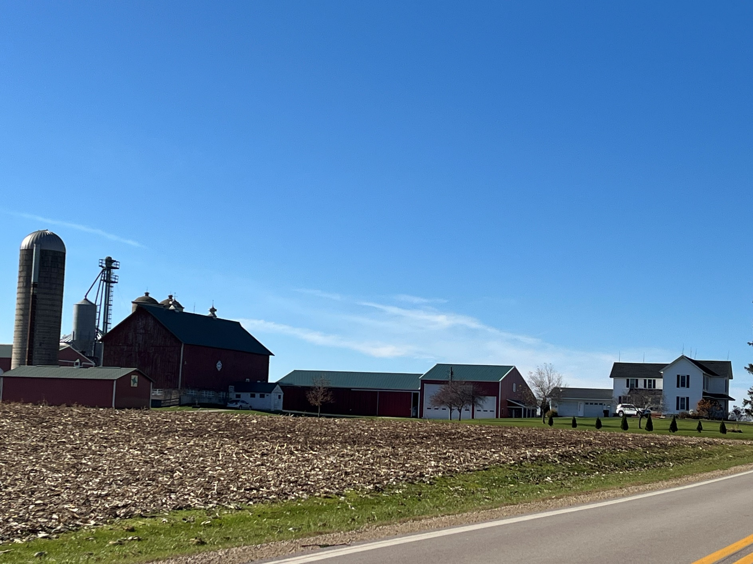

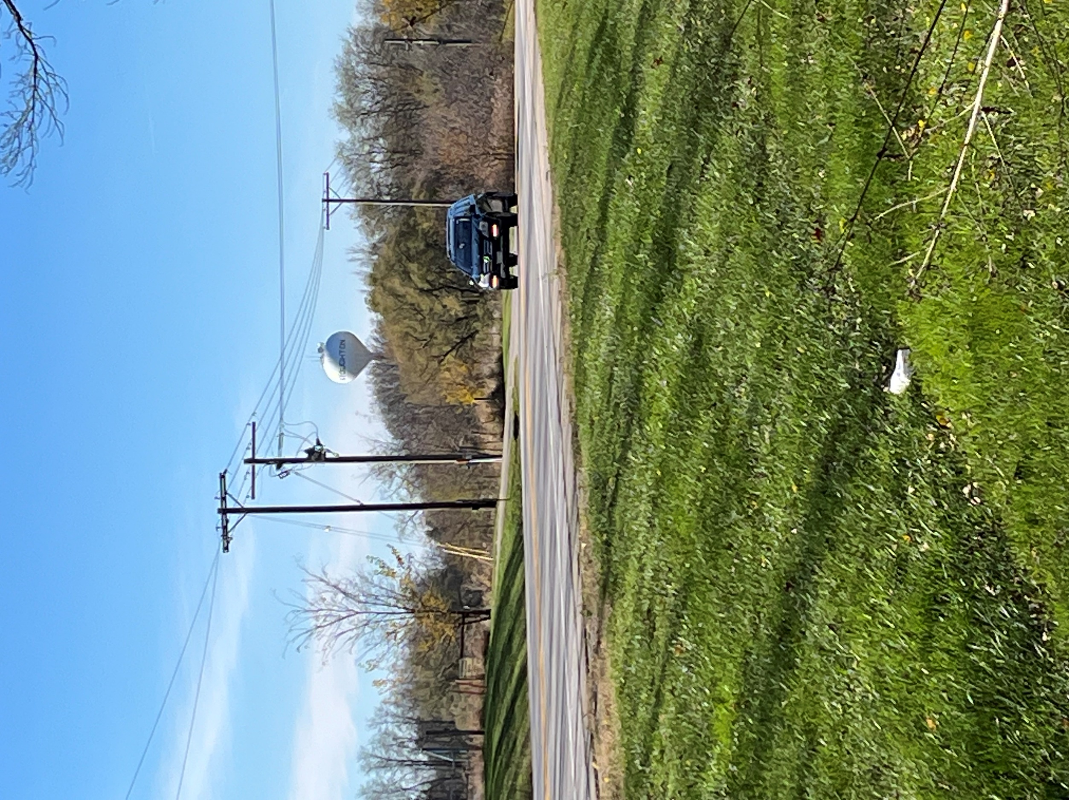element 3:  
Transportation

# Existing Transportation Network

## Roadways

#### Arterials

U.S. Highway 51 and Interstate 90 connect Madison and Janesville, run generally north and south through the northern and eastern part of the town respectively.

#### Collectors

County Trunk Highway A runs generally east to west through the northern section of the town and links to U.S. Interstate 90/39 in the Town of Albion and Highway 51 in the City of Stoughton. County Trunk Highway N runs east to west in the southern section of the town.

#### Town Roads

The Town has 51.6 miles of dedicated town roads. Maintenance, repair and snow removal for the Town roads is performed by the Road Patrolman. These expenses account for more than 80% of the Town annual budget.

## Transit

The closest fixed-route public transit service to the Town of Dunkirk is the Madison Metro Route 65 in the City of Fitchburg approximately 20 miles northwest of the Dunkirk Town Hall.

The closest Park and Ride lot, Dutch Mill, is approximately 16 miles north of the town hall in the City of Madison.

## Taxis and Ride Hail Services

A number of commercial taxi and ride-hail services provide service to portions of the Town of Dunkirk and the Madison metropolitan area.

## Carpool and Vanpool Services

The Greater Madison Metropolitan Planning Organization operates [RIDESHARE, etc](https://www.rideshareetc.org/rp2/Home/Home)., an online ride-matching service to connect commuters with carpooling and vanpool opportunities. The service area includes the Town of Dunkirk. The Wisconsin Department of Administration operates a [vanpool system](https://doa.wi.gov/Pages/StateEmployees/JoinAVanPool.aspx) for commuters (including both state and non-state employees) traveling to and from the downtown Madison area.

## Specialized Transportation Services

Rides for seniors to doctor/dental appointments are available through [RSVP of Dane County Driver Services Program](https://www.rsvpdane.org/programs/driver-services).

The [Dane County Department of Human Services](https://www.dcdhs.com/Disability-and-Aging/Transportation) provides individual and group transportation services for seniors and people with disabilities. Transportation assistance may also be provided for low-income families or persons with unusual medical transportation expenses.

The Greater Madison Metropolitan Planning Organization operates a [number of commuter programs](https://www.greatermadisonmpo.org/rideshare/ForCommuters.cfm) that provide a ride home from work in an emergency to regular carpool, vanpool, mass transit, and bicycle commuters.

## Bicycles and Pedestrians

Shoulders along County and State Highways are rated as suitable for bicycle traffic on the Greater Madison Metropolitan Planning Organization’s [Dane County Bicycle Map](https://cityofmadison.maps.arcgis.com/apps/webappviewer/index.html?id=5d9b5793e6404b8c89872c06bd5f26c2). Additional facilities for dedicated trails are in neighboring Stoughton and along the Yahara River north of Stoughton.

## Rail

The Wisconsin & Southern rail line runs southeast to northwest through Dunkirk. The line continues north to Stoughton and Madison and southeast to Milton Junction.

## Intercity Bus Service

A number of commercial bus lines provide regular passenger service from the City of Madison (approximately 21 miles from the town center) to Midwest destinations, including Milwaukee, Janesville, Beloit, Eau Claire, La Crosse, Chicago, and Minneapolis-St. Paul.

## Trucking

Truck traffic uses the many highways that run through the Town. The town is in close proximity to the Interstate. In addition, Stoughton Trucking and several related trucking businesses on the Dunkirk Stoughton border deploy a significant amount of truck traffic, especially relative to other towns in Dane County.

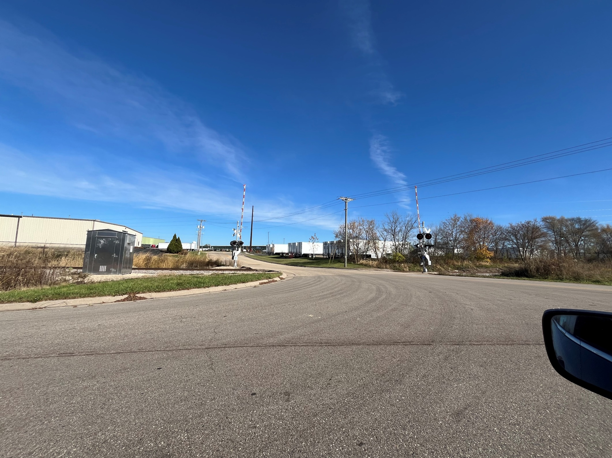

## Water Transportation

The town does not have significant water traffic.

## Airports

The Matson Airport is north of the town off of USH 51. Matson Airport is private, with a grass landing strip of about 3,000 feet. The [Dane County Regional Airport](http://www.msnairport.com/) (MSN) is located in the City of Madison, approximately 22 miles from the Town Hall. Commercial airlines operate daily non-stop flights to 20+ destinations in the continental United States.

## Snowmobile Trails

County trail 5 in the western half and 75 to the east that connects to a club trail. These trails are well connected to a network of trails throughout the County.

# Transportation Plans & Programs

1. The [Regional Transportation Plan 2050 (2017)](http://www.greatermadisonmpo.org/planning/RegionalTransportationPlan2050.cfm) provides an overview of how the region intends to invest in the transportation system across all modes. The plan is required to receive federal highway and transit funding. Completed by the Greater Madison Metropolitan Planning Organization.
2. The [Transportation Improvement Program (TIP)](http://www.greatermadisonmpo.org/planning/improvementprogram.cfm) is a list of transportation improvement projects anticipated to be undertaken in the next five-year period. The TIP is updated annually and is needed to be eligible to receive federal funding. Completed by the Greater Madison Metropolitan Planning Organization.
3. The [Bicycle Transportation Plan](http://www.greatermadisonmpo.org/planning/BikePlan.cfm) (2015) is a cooperative framework for state agencies, Dane County, and local governments in planning for and developing bicycle facilities and programs.
4. The [Dane County Comprehensive Plan](http://www.daneplan.org/plan) (2012) includes countywide goals, objectives, and policies for transportation.
5. [Connections 2030](https://wisconsindot.gov/Pages/projects/multimodal/conn2030.aspx) (2009) is the Wisconsin Department of Transportation's (WisDOT) transportation plan that addresses highways, local roads, air, water, rail, bicycle, pedestrian, and transit needs over a 20-year planning horizon. Planned improvements affecting the Town of Dunkirk are in the [Madison Metropolitan Planning Area](https://wisconsindot.gov/Documents/projects/multimodal/conn2030/maps/madison-mpa.pdf) section.
6. The [Six-Year Highway Improvement Program](https://wisconsindot.gov/Pages/projects/6yr-hwy-impr/overview/default.aspx) (WisDOT, updated annually) identifies capital improvements to the 11,745-mile statewide highway system. Planned improvements affecting the Town of Dunkirk, are contained in the [Southeast Region](https://wisconsindot.gov/Pages/projects/6yr-hwy-impr/proj-info/default.aspx).
7. [Wisconsin Rail Plan 2030](https://wisconsindot.gov/Pages/projects/multimodal/railplan/2030.aspx) (2009) is a vision for freight, intercity passenger and commuter rail, an inventory of Wisconsin’s rail system, rail service and rail facilities, and any known issues.
8. The [State Freight Plan](https://wisconsindot.gov/Pages/projects/sfp/default.aspx) (2018) provides a vision for multimodal freight transportation and positions the state to remain competitive in the global marketplace.

# Goals, Objectives, & Policies

### Goals

1. Support a diversified, safe, efficient, and environmentally-sound transportation network for moving people and providing goods and services through the region.
2. Ensure adequate road and trail capacities and conditions to safely and efficiently accommodate automotive, trucking, agricultural equipment, bicycle, and pedestrian traffic.
3. Provide an adequate network of pedestrian and bikeways throughout the community and with other areas in the region.

### Objectives

1. Provide safe transportation options throughout the town.
2. Coordinate land use and transportation facilities to support one another.
3. Reduce the amount of non-local through traffic in residential subdivisions.
4. Minimize the negative impacts of transportation projects to the greatest extent possible.
5. Work with Dane County and the Wisconsin Department of Transportation to make sure improvements to County Trunk Highways and State Highways support the goals and objectives of this plan.
6. Recognize all applicable state and regional transportation plans and the transportation policies and programs in the Dane County Comprehensive Plan.

### Policies

#### Locate and design transportation projects to minimize negative impacts on neighborhoods, agriculture, and natural, cultural, and historic resources.

#### Limit the number of access points onto town roads when permitting access to private property.

#### Coordinate bicycle, pedestrian, and off-road vehicle routes with road improvement projects.

#### Consider developing Park & Ride lots in or near Stoughton.

#### Coordinate land use and transportation facilities so they support one another.

#### Plan highway improvements concurrently with land use planning and growth management.

#### Evaluate traffic impacts of all development projects and require road improvements where appropriate.

#### Improve safety by installing signs to alert drivers to stops and slower speeds, accommodating wider roads for farm equipment and heavy automobile traffic, and work with the Dane County Sheriff and the State Patrol to enforce traffic regulations and reduce automobile/farm equipment safety problems, and ask the Sheriff for written reports of specific kinds of accidents in the Town.

#### Improve bicycle, pedestrian and agricultural equipment safety on shoulders of town and county roads with the Dane County Public Works, Highways and Transportation Department to improve shoulders on State and County roads.

#### Work with biking organizations to identify biking routes and where possible to expand notification to Town residents.

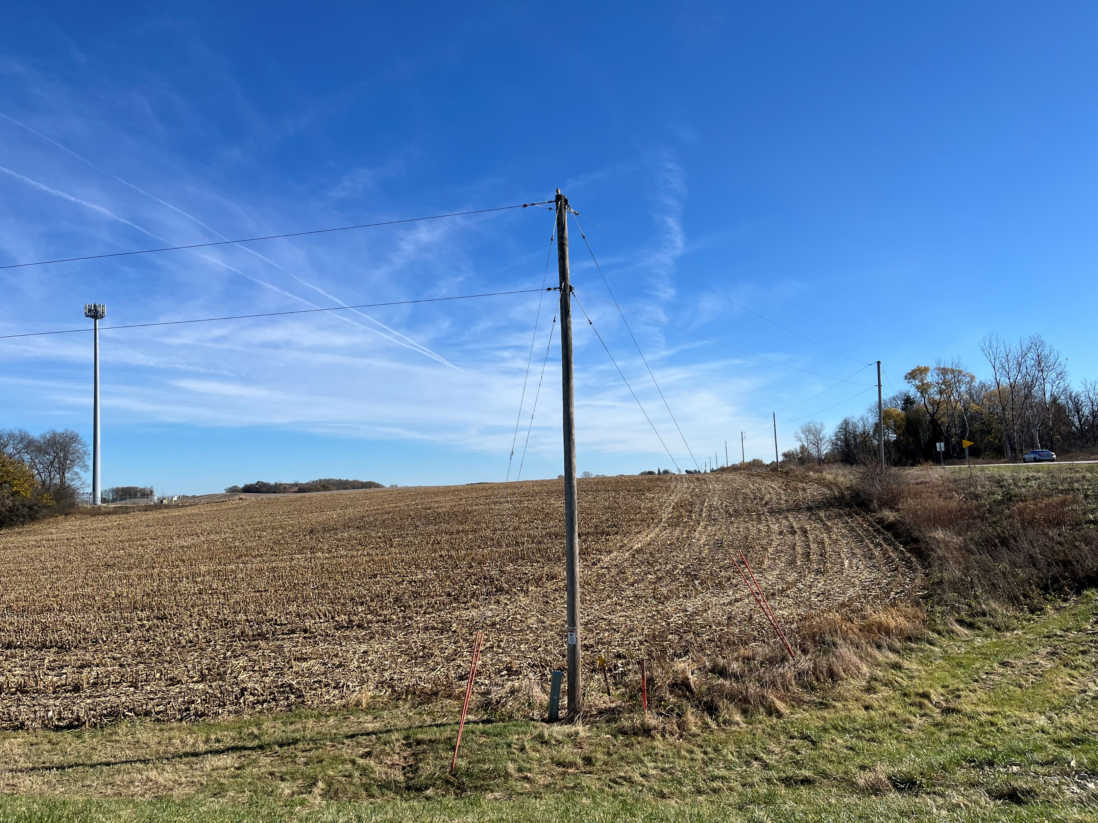element 4:  
Utilities & Community facilties

# Existing Infrastructure & Services

## Town Hall

The Town of Dunkirk’s town hall is located at 654 County Highway N.

## Water Supply

Residents in the town get water from private wells. The town does not offer municipal water service.

## On-Site Wastewater Treatment

Residential and commercial wastewater is handled through on-site disposal and treatment techniques, including: conventional, mound, pressure distribution, at-grade, holding tank, and sand filter systems. Because of the low population density, there is no municipal sewer service.

## Solid Waste Disposal and Recycling Facilities

The town offers trash and recycling curbside through a local contractor, John’s Disposal. The charges for this service are included in the municipal property taxes. The Town of Dunkirk is served by the [Dane County Sanitary Landfill](https://pwht.countyofdane.com/recycle/landfill.aspx), operated by the Dane County Public Works, Highways, and Transportation Department. The [Dane County Clean Sweep Program](http://www.danecountycleansweep.com/), housed at the landfill, provides for disposal of hazardous wastes.

## Stormwater Management

The town follows Dane County’s Erosion Control and Stormwater Management Ordinance (Chapter 14 Dane County Code of Ordinances). The Ordinance sets standards for the quality and quantity of runoff from areas in rural and farm areas where requested alterations in the landscape may result in changes in the amount and quality of water running off site.

## Law Enforcement

The town falls entirely within the S3 Dane County Sheriff District.

## Fire Protection and Emergency Medical Service (EMS)

The Stoughton Fire and EMS serve the Town of Dunkirk.

## Cemeteries

Dunkirk does not have any cemeteries. The nearest cemetery is the Dunn Burying Ground on Sand Hill Road.

## Libraries

Town residents have access to three libraries within a 20-minute drive: Madison Pinney, Monona, and Fitchburg public libraries. All of these libraries participate in the South-Central Library Service shared collection access.

## Schools

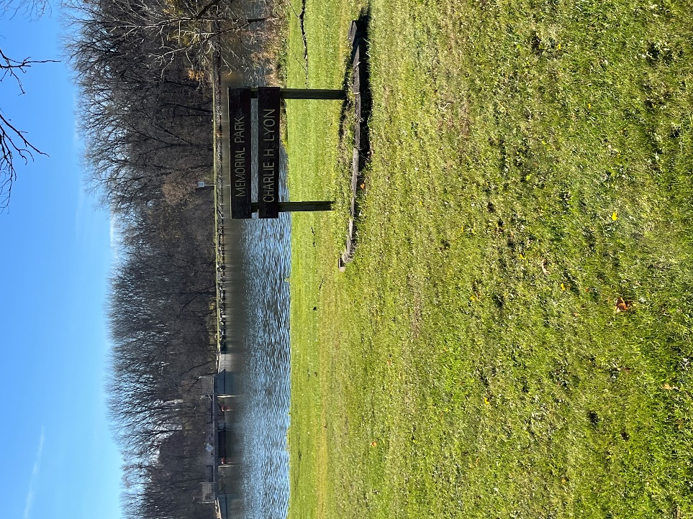Two school districts serve the town: Stoughton Area School District covers the majority of the Town and Edgerton Area School Districts covers the south east corner.

## Parks and Recreational Facilities

Pleasant View and Dunkirk Parks in Stoughton and Dunkirk Dam Park in the Town along the Yahara River are the closest parks available to residents.

## Health Care Facilities

The town does not contain health care facilities. Stoughton provides several medical care facilities, including Stoughton Hospital, UnityPoint Health- Meriter, SSM Health Dean, UW Health, Nazareth Health and Rehabilitation Center, Neighborhood Free Health Clinic. The closest nursing homes are located in Stoughton, Edgerton, and Evansville.

## Child Care Facilities

At this time there are no childcare centers in the town. Small, in-home childcare services may exist from time to time. The nearest facilities are in Stoughton, Edgerton, and Evansville.

## Faith Based Facilities

Cooksville Lutheran Church in Evansville and several churches in Edgerton and Stoughton catering to Methodists, Mormons, Lutherans, Catholics, Universalists, Pentecostals, Baptists, and others serve Dunkirk residents.

## Senior Services

Senior centers near the Town of Dunkirk are located in the City of Stoughton, with more than 5 options, Edgerton with one option, and Evansville with two options. The Stoughton Senior Center, a non-profit, also serves area residents during the weekdays.

* The [Aging and Disability Resource Center](http://www.daneadrc.org/) (ADRC) of Dane County provides information about resources and support related to aging and/or living with a disability, long-term care options, and public benefits. ADRC services are free and available to all County residents.
* The [Area Agency on Aging of Dane County](https://aaa.dcdhs.com/) provides people age 60+ and their families assistance accessing services that help older adults stay in their homes and communities.

## Other Community Services

Town of Dunkirk residents can access more than five food pantries in the City of Stoughton (3), Evansville (1), and Edgerton (1). Youth centers are also in each of the neighboring municipalities

## Telecommunications Facilities

Two telecommunication towers are located in the town. Two others are located in the City of Stoughton. The surrounding towns feature two or more towers each.

## Broadband

Large areas in the Town of Dunkirk lack sufficient broadband internet coverage.

## Power Plants and Transmission

The Town of Dunkirk is in the Wisconsin Power & Light Company service area.

# Service Demand Forecast

Due to the anticipated population decline for the Town of Dunkirk, existing utilities and public facilities are expected to be sufficient to meet demand for the next twenty years. One exception, broadband internet access, is insufficient to meet demand.

# Goals, Objectives, & Policies

### Goals

* 1. Continue to cost effectively maintain the Town’s infrastructure at a level of service desired by Town residents, farmers, and businesses.
  2. Continue to cost effectively maintain public services desired by Town residents and businesses.

### Objectives

* 1. Alleviate the impacts of stormwater runoff on the town.
  2. Ensure residents have convenient and cost-effective solid waste and recycling services.
  3. As feasible, accommodate recreational amenities of interest to residents and plan for adequate recreational opportunities for future residents.

### Policies

1. Make the Town Hall available for residents to use for family functions.
2. Allow residents to borrow folding chairs and tables for family functions.
3. Support the county’s “Clean Sweep Program” to collect and safely dispose of household hazardous waste.
4. Encourage town residents to reduce the household waste they generate.
5. Provide brush disposal services at the landfill site.
6. Cooperate with other municipalities and governmental agencies to maximize cost-efficient delivery of services.
7. Work with neighboring communities to ensure development that occurs within those communities does not contribute to stormwater runoff problems in the town.
8. Require the use of on-site stormwater management facilities when needed to control stormwater runoff.
9. Encourage green building technologies and practices be used in designing, constructing, and maintaining facilities.
10. Allow development at densities that are cost-effective to serve.
11. Increase recreational opportunities for all ages, such as bike and pedestrian trails.
12. Include residents in the management and design of public parks.
13. Recognize the goals, objectives, and policies and programs of the Dane County Comprehensive Plan for utilities and community facilities, including those for sanitary sewer service, storm water management, water supply, solid waste disposal, on-site wastewater treatment, recycling facilities, parks, telecommunication facilities, power plants and transmission lines, cemeteries, health care facilities, child care facilities, police, fire, rescue, libraries, schools, and other governmental facilities.
14. Work to improve the availability, affordability, and adoption of telecommunication and high-speed broadband internet services.
15. Encourage pre-planning of utility corridors by towns and the counties. Work with the state legislature to require utility companies to use pre-planned corridors identified in county comprehensive plan, or existing transportation corridors.
16. Ensure new renewable energy facilities comply with town siting, design, and decommission standards described in Element 8 of this plan.
17. Explore and plan for future options to manage solid and liquid waste (manure).
18. Develop policies to manage placement of cell towers that minimize impacts to the Town’s rural character and the environment.
19. Work with the County of Dane’s Broadband Coordinator to:
    1. Pursue expansion funding opportunities,
    2. Partner with service providers that serve or could serve Dunkirk.
    3. Use available maps and data to identify underserved and unserved areas.
    4. Consider adding conduit access in the Right of Way during road reconstruction.
    5. Consider adopting the Broadband Forward! model ordinance to streamline administrative procedures and reduce obstacles to broadband infrastructure investment.

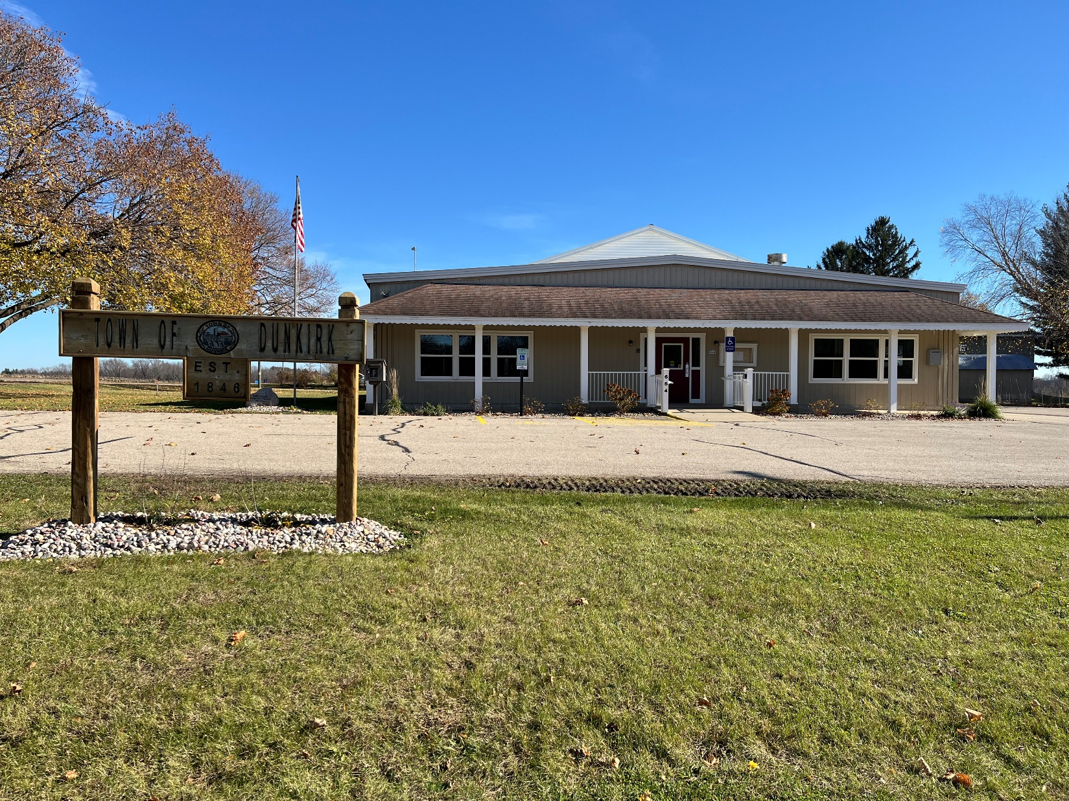

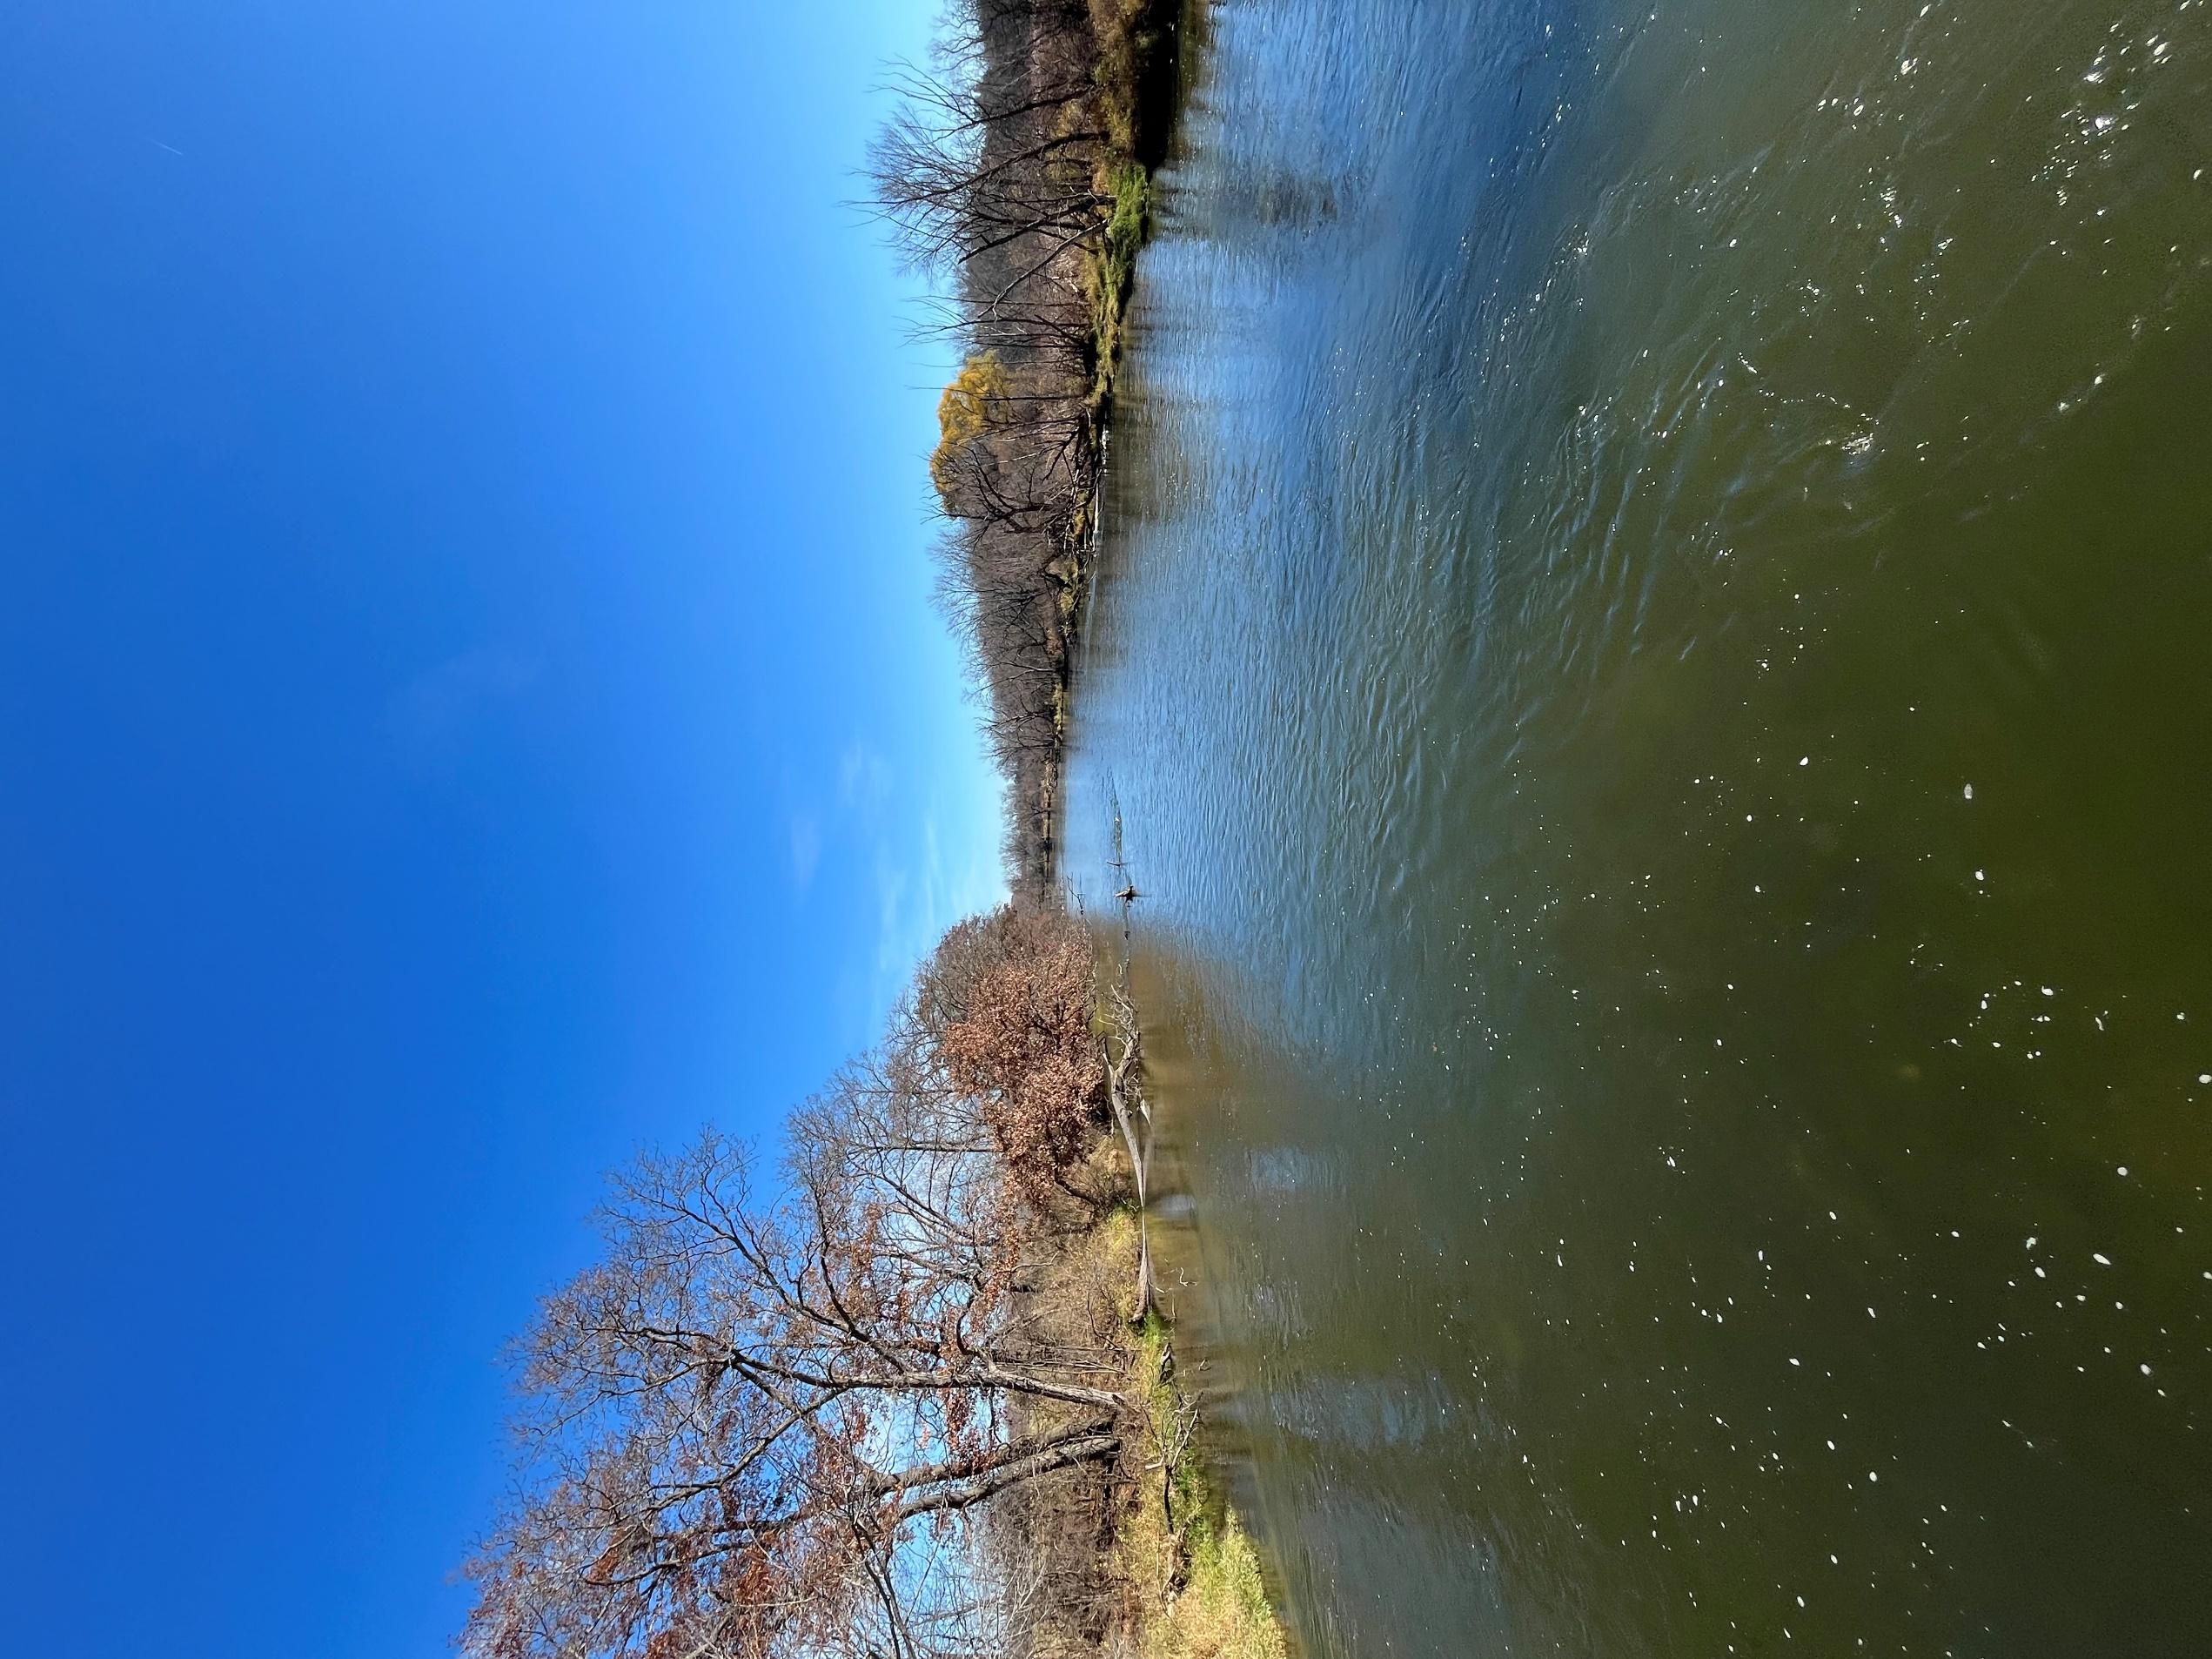element 5:  
Agricultural, Natural, & Cultural Resources

# Agricultural Resource Inventory

## Historic Trends

In the Town of Dunkirk, land in agricultural use accounted for 13,696 acres, or 68% of the town land area in 2020. Crop and pasture declined by approximately 2000 acres between 1990 and 2020 *(Dane County Land Use Inventory).* Woodland/other open land and water increased by 1,990 acres Note, some of these differences may be accounted for by improvement in measuring features such as water which increased more than 125 acres, or woodlands, which nearly doubled from 1990 to 2020.

Figure 14: Agriculture Comparison to All Other Land Uses 1990-2020

Source: 2020 Dane County Land Use Inventory

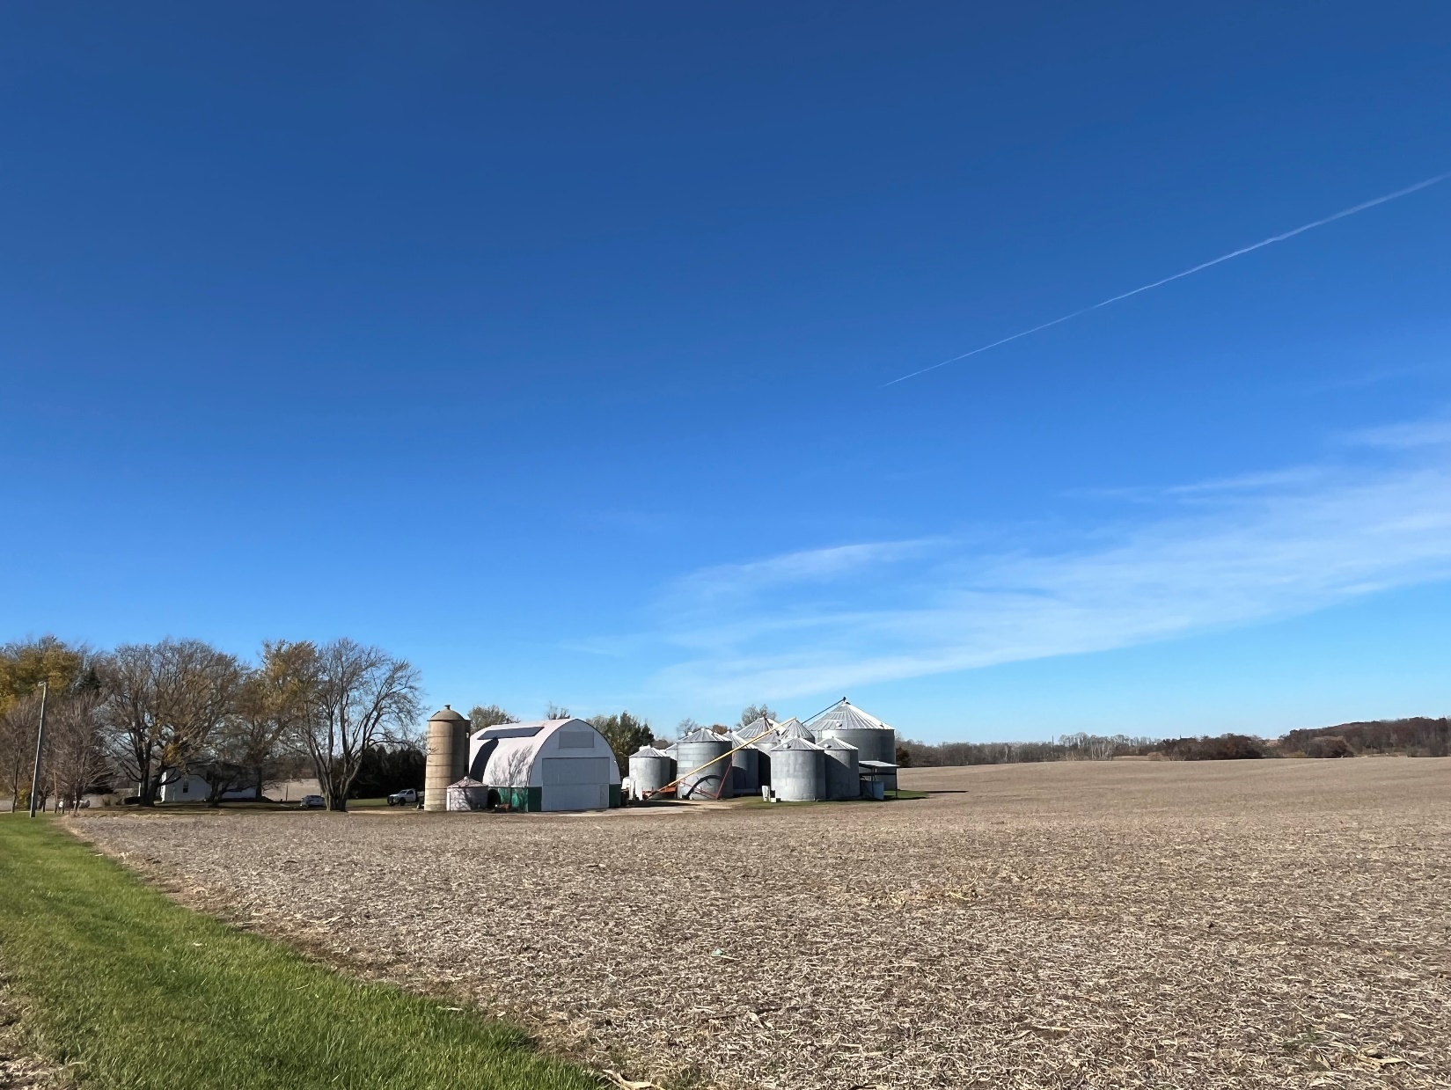

## Existing Farming

Sixty-eight percent of the land was in agricultural use in 2020 with the majority of these lands dedicated rotational crops, with less than 1% dedicated to pasture or hay/alfalfa crops, and 1% in woodland.

Table 2: Land in Agricultural Use 2010-2020 (acres)

| **Description** | **2010** | **2020** | **Change 2010-2020** |
| --- | --- | --- | --- |
| Corn farming | 7,763.0 | 7,160.2 | -602.8 |
| Hay/alfalfa farming | 1,212.1 | 940.1 | -272.1 |
| Soybean farming | 3,991.4 | 4,806.5 | 815.2 |
| Pasture (fenced areas near farm buildings) | 297.8 | 220.9 | -76.9 |
| Wheat farming | 62.4 | 223.4 | 161.0 |
| Farm residence, access road | 100.1 | 88.9 | -11.2 |
| Nursery and tree production | 12.9 | 7.7 | -5.2 |
| Dairy cattle and milk production | 18.5 | 15.2 | -3.3 |
| Beef cattle ranching/farming, incl. feedlots | 27.5 | 60.3 | 32.7 |
| Fallow farm field | 23.2 | 66.1 | 42.8 |
| All other animal production | 0.9 | - | -0.9 |
| All other farm related buildings | 231.6 | 162.4 | -69.2 |
| Polyculture/Community supported agriculture | 2.6 | 2.5 | -0.1 |
| Large scale grain elevators, Cooperative | 4.6 | 1.5 | -3.1 |
| Sheep farming | 2.5 | 3.8 | 1.3 |
| Non-citrus fruit and tree nut farming | 12.0 | - | -12.0 |
| Horses and other equine production | - | 1.8 | 1.8 |
| **Total land in agricultural use** | **21,750.7** | **21,736.4** | **-14.3** |

Source: Dane County Land Use Inventory 2010, 2020.

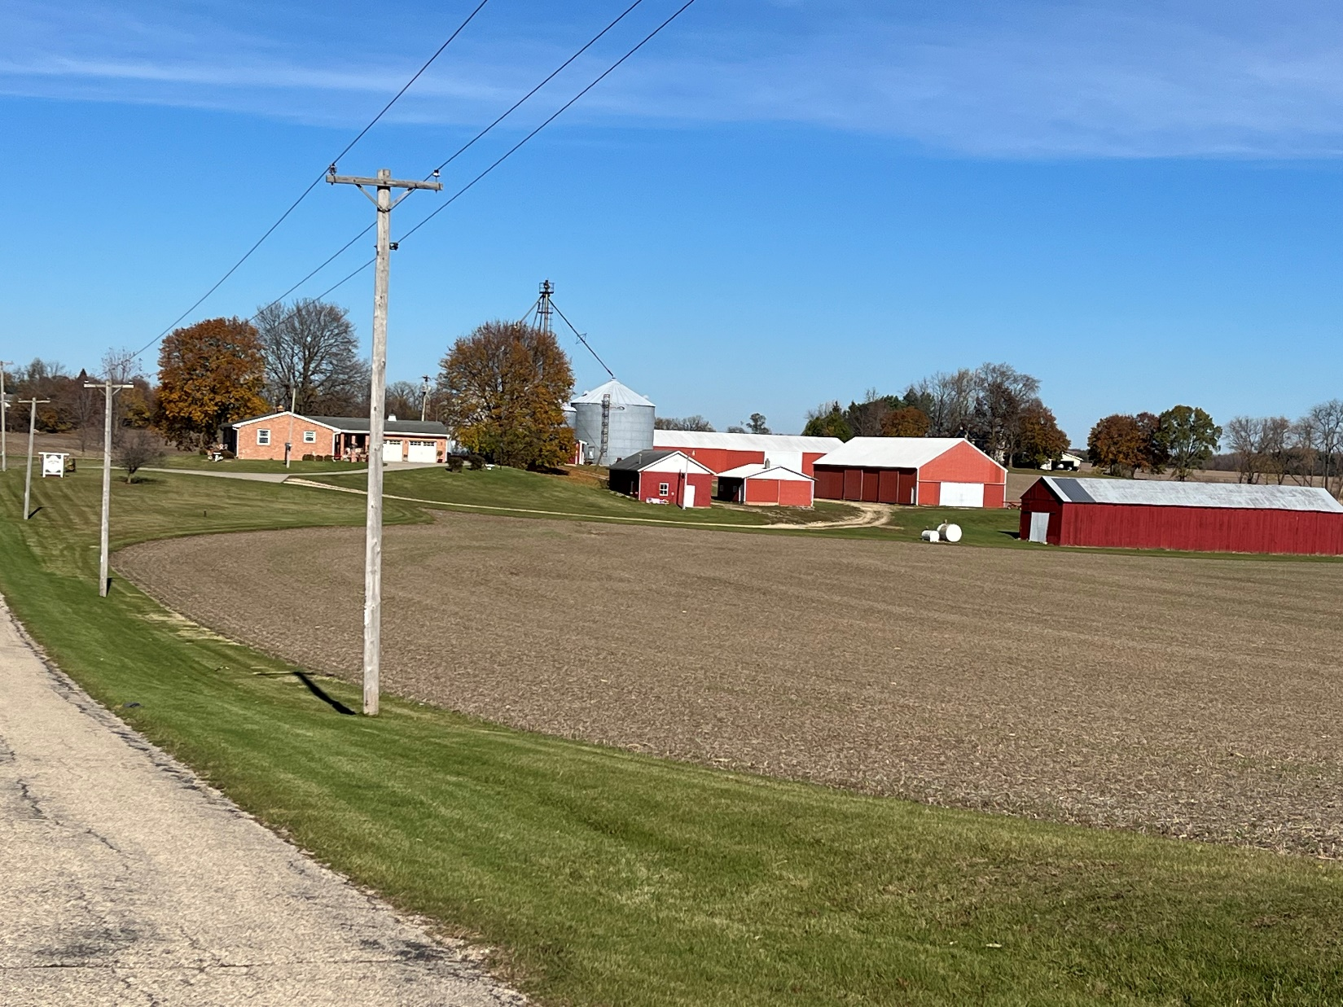

Figure 15: Major Agricultural Uses by Acreage (2020)

Source: Dane County Land Use Inventory 2010, 2020.

## Agricultural Property Size and Scale

The Dane County Zoning Ordinance (Chapter 10, Dane County Code) defines a *farm* as “All land under common ownership that is primarily devoted to agricultural use.” In 2020, 137 landowners (individuals or groups of individuals) had a majority of their property in agricultural use and could be considered a “farm.” Farms ranged from 10 acres to 439 acres in size, with an average area of 94 acres.

Figure 16: Distribution of Acres

Source: Land Use Inventory

## Future Prospects

Because of the Town’s strong density policy, agricultural practices will likely continue over the next twenty years. Global, national, and regional market factors may affect the type of farming in the Town.

# Natural Resources Inventory

## Environmentally Sensitive Areas

Wetlands and floodplains are found along the Yahara River, and throughout various other areas of the town. In addition, hydric soils are found in many other areas. Hydric soils are defined as soils that are formed under conditions of saturation, flooding or ponding long enough during the growing season to develop anaerobic conditions in the upper part. They are one of three criteria used for delineating wetlands, therefore the presence of hydric soils indicates that the presence of wetlands should be considered.

Some smaller areas having steep slopes, or slopes greater than 12.5 percent, are also found throughout Dunkirk. Although these slopes do not prohibit development, they create additional considerations including a greater need for post-development erosion control, and issues with road construction, maintenance, safety, undue diminishment of rural character, and others. It is also important to recognize that areas with slopes greater than 12 percent are typically designated as environmental corridor at the time the land is brought into the urban service area.

A small area of the town, adjacent to Stoughton, is designated as environmental corridor. Environmental corridors, as delineated by the Dane County Regional Planning Commission, are systems of open space within the urban service area that include environmentally sensitive lands, natural resources requiring protection from disturbance and development, and lands needed for recreation and open space. These areas are delineated to help local governments and other agencies make decisions regarding the location of development. An important reason to define and map the corridors is for the review of sewer extensions and sewer service areas, to direct urban development to areas outside the environmental corridors.

## Soils

The majority of the town is considered prime farmland, based on soil characteristics. Soils are classified by the U.S. Department of Agriculture, Natural Resources Conservation Service according to their suitability for growing most kinds of field crops. Soils are grouped into eight different classes. Class I, II, and III are considered prime farmland.

Hydric soils and soils with hydric inclusions also follow the streams and rivers, especially in the lower Yahara River basin. Hydric soils may, in time, revert to wetland conditions if no longer drained or cropped. Hydric soils present a variety of practical difficulties for construction and development should be avoided. The Dane County Zoning Division typically requires wetland delineations for proposed fill or construction near hydric soils.

## Wetlands

Complex wetlands are found throughout the town with concentrations near the Yahara River and the rail corridor. Dane County’s Shoreland and Wetland Zoning Ordinance (Chapter 11, Dane County Code) regulates development in and near wetlands. The Wisconsin DNR Natural Heritage Inventory does not identify endangered or threatened wetland habitats in the Town.

## Groundwater

Dunkirk provides high levels of groundwater recharge, up to 9 to 11 inches/year throughout the town. In Dunkirk, groundwater supplies nearly all the water for domestic, commercial, and industrial uses. Therefore, it is extremely important to protect the groundwater from excessive road salt, fertilizer, pesticides and poor maintenance of animal waste and septic systems.

## Wildlife and Endangered Species

The Wisconsin DNR Natural Heritage Inventory identifies the following endangered or threatened species or species of special concern as potentially present in the Town.

Figure 17: Wisconsin DNR Natural Heritage Inventory

| **Common Name** | **Scientific Name** | **WI Status** | **Federal Status** | **Group** |
| --- | --- | --- | --- | --- |
| Black-crowned Night-Heron | [Nycticorax nycticorax](https://apps.dnr.wi.gov/biodiversity/home/detail/animals/6164) | Special Concern |  | Bird |
| Black Tern | [Chlidonias niger](https://apps.dnr.wi.gov/biodiversity/home/detail/animals/6329) | Endangered | Concern | Bird |
| Rusty Patched Bumble Bee | [Bombus affinis](https://apps.dnr.wi.gov/biodiversity/home/detail/animals/11020) | NA | High Potential Zone | Bee |
| Bald Eagle | [Haliaeetus leucocephalus](https://fws.gov/story/do-i-need-eagle-take-permit) |  |  | Bird |
| Black-crowned Night-Heron | [Nycticorax nycticorax](https://apps.dnr.wi.gov/biodiversity/home/detail/animals/6164) | Special Concern |  | Bird |

Source: [WIDNR - Natural Heritage Inventory (NHI) Township Data (wisconsin.gov)](https://dnrx.wisconsin.gov/nhiportal/public/data/township)

## Woodlands

In 2020, the Town of Dunkirk had approximately 1,400 acres of woodland, which is 7% of the Town land area. Expanses of wooded areas occur along the Yahara River and throughout the town.

## Mineral Resources

According to county permitting data, there is one active mineral extraction site in the town on Highways 138 and A. Ozinga is actively operating half of the permitted area.

# Cultural Resources Inventory

## Historic Sites

The Wisconsin Historical Society’s Architectural Heritage Inventory (AHI) identifies forty-four (44) structures of historic interest in the Town of Dunkirk, notably associated with the Quale, Thorson, and Austinson-Asbjornson-Holte Farmsteads. The Savage and Ingebretson, Gaute Loft Houses are listed on the National and State Register of Historical Places.

Table 3: Historic Architectural Resources

| **Id Number** | **Historic Use** | **Name/Other Name** | **Style** | **Year Built** |
| --- | --- | --- | --- | --- |
| 4495 | House |  | Gabled Ell | - |
| 4496 | House |  | Queen Anne | - |
| 4500 | House | Gaute Ingebretson Loft | Front Gabled | 1844 |
| 4501 | Barn |  | Astylistic Utilitarian | - |
| 4502 | House |  | Other Vernacular | - |
| 4503 | House |  | Two Story Cube | - |
| 4504 | House |  | Queen Anne | - |
| 4505 | Power Plant | Stoughton Power Plant No.2 | Neoclassical/Beaux Arts | 19-27 |
| 4506 | House |  | Other Vernacular | - |
| 4507 | House |  | Front Gabled | - |
| 4508 | House |  | Gabled Ell | - |
| 4509 | House |  | Gabled Ell | - |
| 4499 |  |  |  | - |
| 12578 | Barn |  | Astylistic Utilitarian | - |
| 81055 | Dam | Dunkirk Dam | -NA | 1915 |
| 93109 | House |  | Two Story Cube | - |
| 93043 | House |  | Two Story Cube | 0 |
| 158662 | House | Quale Farmstead | Side Gabled | 1875 |
| 162782 | Dairy Barn | Quale Farmstead | Astylistic Utilitarian | - |
| 162801 | Pig Shed | Quale Farmstead | Astylistic Utilitarian | 1915 |
| 162802 | Horse Stable | Quale Farmstead | Astylistic Utilitarian | 1915 |
| 162781 | Tobacco Barn | Quale Farmstead | Astylistic Utilitarian | - |
| 162881 | Tobacco Barn | Quale Farmstead | Astylistic Utilitarian | 1915 |
| 162921 | Silo | Quale Farmstead- Silo 2 | NA | 1915 |
| 162922 | Silo | Quale Farmstead- Silo 3 | NA | 1940 |
| 186201 | House | Thorson Farmstead | Gabled Ell | 1870 |
| 186221 | Barn | Thorson Farmstead | Astylistic Utilitarian | 1902 |
| 186321 | Tobacco Barn | Thorson Farmstead | Astylistic Utilitarian | 1915 |
| 186261 | Chicken Coop | Thorson Farmstead | Astylistic Utilitarian | - |
| 186241 | Silo | Thorson Farmstead | NA | 1915 |
| 186301 | Windmill | Thorson Farmstead | NA | - |
| 186281 | Shed | Thorson Farmstead | Astylistic Utilitarian | 1848 |
| 186242 | Granary | Thorson Farmstead | Astylistic Utilitarian | - |
| 225638 | House | Austinson-Asbjornson-Holte | Italianate | 1860 |
| 225641 | Tobacco Barn | Austinson-Asbjornson-Holte | Astylistic Utilitarian | 0 |
| 225640 | Dairy Barn | Austinson-Asbjornson-Holte | Astylistic Utilitarian | 0 |
| 225639 | Outbuilding | Austinson-Asbjornson-Holte | Astylistic Utilitarian | 0 |
| 225642 | Machine Shed | Austinson-Asbjornson-Holte | Astylistic Utilitarian | 1940 |
| 225726 | Outbuilding | Austinson-Asbjornson-Holte | Astylistic Utilitarian | 0 |
| 225789 | Outbuilding | Austinson-Asbjornson-Holte | Astylistic Utilitarian | 0 |
| 225790 | Garage | Austinson-Asbjornson-Holte | Astylistic Utilitarian | 0 |
| 225796 | Swimming Pool |  |  | 0 |
| 9902 | House | Savage House | Side Gabled | 1848 |
| 225718 | Barn |  | Astylistic Utilitarian | 1890 |

Source: Wisconsin Historical Society’s Architectural Heritage Inventory

## Archaeological Sites

Under Wisconsin law, Native American burial mounds, unmarked burials, and all marked and unmarked cemeteries are protected from intentional disturbance. The Wisconsin Historical Society maintains the Archaeological Site Inventory (ASI). The ASI is the most comprehensive list available. Nevertheless, the ASI ONLY includes sites that are reported to the Wisconsin Historical Society. Detailed site information is protected by State and Federal law to protect archaeological features and property owners.

Since only a small portion of the Town is surveyed for archaeological sites and cemeteries, the inventory shows a fraction of the sites that may be present. Residents and Native Americans of the area likely possess information on other archaeological sites. At this time, sixteen (16) archaeological sites and cemeteries are recorded (Table 5-4).

Table 4: Archaeological and Burial Sites

| **ID** | **Name** | **Site Type** | **Culture Name** |
| --- | --- | --- | --- |
| 11941 | Catfish Ford | Transportation site | Historic Native American |
| 11539 | Nelson Wigwam | Campsite/village | Unknown Prehistoric |
| 11960 | Webb | Campsite/village, garden | Historic Native American |
| 11832 | Taylor | Campsite/village | Historic Indian |
| 11953 | Dunkirk | Campsite/village; Cabin | Historic Euro-American; Unknown Prehistoric |
| 11825 | Johnson I | Campsite/village | Unknown Prehistoric |
| 11952 | Bitter Camp Site | Campsite/village | Historic Native American |
| 11830 | Burull | Campsite/village | Woodland |
| 11537 | Moore | Campsite/village | Unknown Prehistoric |
| 11536 | Schieldt | Campsite/village | Historic Native American; Unknown Prehistoric |
| 11538 | Bitter Farm | Campsite/village; Cemetery | Historic Native American; Unknown Prehistoric |
| 12994 | Leslie Rd. Cemetery | Cemetery/burial | - |
| 3732 | - | Active | - |
| 3728 | - | Active | - |
| 3730 | - | Active | - |
| 8734 | - | Active | - |

Source: The Archaeological Site Inventory 2023

## Community Design

The town incorporates community design guidelines. When reviewing development proposals, the Town and property owners will consider these Town objectives:

* Avoid disturbance of land with a history of agriculture,
* Avoid disturbance of floodplains, wetlands and steep slopes,
* Minimize number and length of driveways, and
* Avoid fragmentation of existing contiguous wood lots of 20 acres or more.

See Element 8: Land Use for detailed design and siting criteria.

# Goals, Objectives, & Policies

## Agricultural Resources

### Goals

1. Preserve productive farmlands in the town for continued agricultural use.
2. Keep farming economically viable through the 21st century in the Town of Dunkirk.
3. Maintain the rural character of the town.

### B. Objectives

1. Discourage incompatible land uses and activities that may adversely affect the capital investment in agricultural land, improvements, and equipment.
2. Direct nonfarm development away from productive agricultural soils to areas with appropriate public services.
3. Limit nonfarm development using density policies.
4. Support efforts to provide economic opportunities for farmers.

### Policies

1. Limit nonfarm uses in agricultural preservation districts to one unit per 40 acres owned as of July 1, 1979 (see Element 8: Land Use).
2. Allow rezones for nonfarm development only on lands that meet town siting, lot design, and driveway criteria (see Element 8: Land Use).
3. Help farmers understand their eligibility for farmland preservation tax credits and other programs that encourage continued farming.
4. Town ordinances that restrict noise, odors, keeping of animals, etc. shall not apply to farming activities in agricultural preservation districts.
5. Encourage farmer participation in cost-share and other programs as described in the Dane County Land & Water Resources Plan.
6. Encourage and participate in farmer education programs through UW Extension.
7. Consider new tools, such as TDR and PDR, to help protect agricultural lands and provide financial alternatives to developing farmland (See Element 8: Land Use).
8. Work with Dane County to revise county zoning and land division ordinances to support farm operations and agriculture-related businesses.

## Mineral Resources

### Goals

1. Make sure mineral extraction operations protect public health, safety and the environment and are consistent with the goals and objectives of this plan.
2. Limit conflicts between mineral extraction and incompatible uses.

### Objectives

1. Establish clear, consistent policies for conditional use permits for mineral extraction operations. See Element 8, Land Use.
2. Work closely with Dane County to review and provide appropriate conditions for proposed mineral extraction operations. See Element 8, Land Use.
3. Discourage development that would conflict with existing mineral extraction operations.
4. Help identify significant mineral deposits within the town inventory inactive unreclaimed mineral extraction sites.

### Policies

1. Require conditional use permits for new or expanding mineral extraction sites and recommend conditions for approval based on the nature of the operation, location, topography, other natural resources, and public comment received.
2. Work with Dane County as necessary to develop specific conditions related to, at a minimum:
   1. Hours of operation,
   2. Conditions on schedule, community notification of and nature of blasting (if any),
   3. Truck traffic and safe routes for material hauling,
   4. Other uses on the site, such as crushing or asphalt production,
   5. Fencing, screening, and warning signs, and
3. Final use of a reclaimed site must be consistent with other goals, objectives, and policies in this plan.

## Natural Resource

### Goals

1. Protect important natural features such as significant woodland, oak savannah, and grassland areas, floodplains, wetlands, endangered species habitat, shorelands, river corridors, ponds, and steep slopes.
2. Protect and, where possible, improve surface and groundwater quality.
3. Provide sufficient parks and outdoor recreation areas to meet the needs of town residents.
4. Provide for sustainable, diverse hunting, fishing, wildlife observation and other outdoor activities within the town.
5. Support and encourage voluntary stewardship of private and public lands.

### Objectives

1. Establish a resource protection district, with policies to help protect sensitive environmental areas, including floodplains, wetlands, and steep slopes.
2. Establish a public lands district with policies to help foster cooperation with public agencies owning land in the town and promote consistency with this plan.
3. Ensure development uses best practices to minimize impacts to natural resources.
4. Direct development requiring public sewer and water to designated Urban Service Areas.
5. Where possible, limit fragmentation of valuable natural resources and try to connect separated wildlife habitats to maintain robust viable populations.

### Policies

1. Guide the location and design of development that minimizes adverse impact on the quality of surface waters, aquifers, wetlands, woodlands, and oak savannahs.
2. Implement Dane County on erosion control, stormwater, floodplain, wetland, and shoreland regulations.
3. Support cost-share, farm conservation plans, and other efforts described in the Dane County Land & Water Resources Plan.
4. Work cooperatively with municipal, county, state and federal public agencies and nonprofits owning land in the Town to:
   1. participate in public acquisition planning processes,
   2. develop agreements on future use of existing public lands,
   3. assure input from Town officials and citizens, and
   4. provide a better understanding of financial resources and funding mechanisms available for land acquisition and management.
5. Support water conservation and proper land use planning in the Yahara River – Lake Kegonsa Watershed and all sub units.
6. Consider Transfer of Development Rights (TDR) and other programs to protect natural resources and give landowners alternatives to development. Give priority to tools and incentives that complement and support other voluntary conservation efforts in the town, such as the DNR’s Southwest Grassland and Stream Conservation Area.
7. Review town siting criteria, design and development guidelines to make sure they adequately protect the rural character of the town, and avoid environmental impacts. The town should consider whether future amendments to the Town of Dunkirk Comprehensive Plan should address issues such as:
   1. Development, landscaping or design guidelines for ridgetops to reduce impacts to scenic vistas and prevent erosion.,
   2. Establishing limits on tree removal to protect woodlands and avoid fragmentation of habitat, and/or
   3. Using downward-directed lighting to protect dark skies and avoid unnecessary light pollution.

## Cultural Resources

### Goals

Protect and preserve the town's historic and archaeological resources.

### Objectives

1. Encourage identification, protection, interpretation, and maintenance of all significant cultural sites in the town.
2. Encourage identification, protection, preservation, and restoration of buildings and sites that highlight the town’s cultural history, especially those that could be listed on the National Register and/or the State Register of Historic Places.
3. Increase public awareness and appreciation of the town’s historic and archaeological resources.

### Policies

1. Support local, county, state, and federal historic preservation efforts.
2. Provide relevant property owners information about restoration grants, technical assistance, and recognition programs.
3. Consider potential for providing modest incentives for landowners to maintain or restore historic properties.
4. Support efforts to document and research historic and archaeological sites in the town. Work with the Stoughton Public Library and Wisconsin Historical Society to provide interpretative materials, plaques, or markers for Town of Dunkirk sites of statewide or regional interest. Maintain access to these resources on the town website.
5. Work with the City of Stoughton Historical Society, other historical societies, faith based organizations, Native American tribes, and residents to educate and provide interpretation of town historic sites, rural schools, and document the written and oral history of the town.
6. Consider whether the town should appoint a town historian and/or help establish a Town of Dunkirk Historical Society. Make meeting space available in the Town Hall.
7. Support local festivals, ethnic celebrations, farm tours, farm breakfasts, and markets that celebrate the town’s history, heritage, and rural way of life.
8. Conduct regular surveys of town residents about types of activities, pastimes, hobbies, sports, performances, handiwork, music, art, dance, theater, religion or other cultural practices, including information about the physical locations where such activities take place.

### Programs

1. Federal Historic Preservation Tax Credit program enables historic property owners to get 20% of expenses to rehabilitate their historic commercial, industrial, and rental residential properties back through the property taxes. Owners of these properties can also claim a 5% Wisconsin Historic Preservation Tax Credit. Improvements must comply with the US Secretary of Interior’s Standards for Historic Building Rehabilitation guidelines.
2. Wisconsin Historic Preservation Tax Credit program provides 25% of expenses to rehabilitate owner-occupied homes and structures that contribute to a National Register-listed historic district, are individually listed, or eligible for listing with the National or State Register. To qualify, expenditures must exceed $10,000, and the Wisconsin Historical Society must certify that the work is compatible with the building’s historic character.

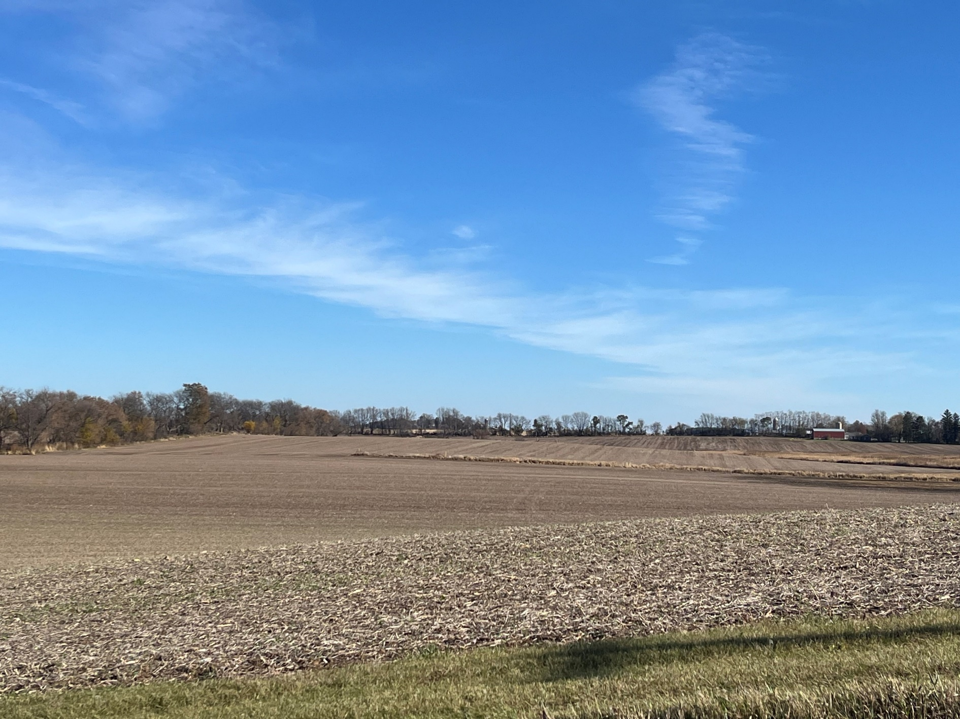The Wisconsin Historical Society maintains a list of other public and private funding sources for historic preservation projects.

ELEment 6:  
Economic Development

Insert picture

# Economic Base

## Labor and Income

### Labor Force

Approximately 70% of the town’s population aged 16 and older over participated in the labor force, slightly less than participation rate for Dane County as a whole, and slightly more than Wisconsin.

Figure 18: Labor Force Participation Rate (Population 16+ Years Old)

Source: [American Community Survey 5-year averages](https://data.census.gov/vizwidget?g=060XX00US5502517800&infoSection=Poverty) 2018-2022

### Median Income

In 2022, Town of Dunkirk households had a median income of $90,833, 7% higher than the $84,297 median for Dane County as a whole.

Figure 19: Median Income for Households and Families

Source: [American Community Survey five-year averages](https://data.census.gov/vizwidget?g=060XX00US5502517800&infoSection=Poverty) 2018-2022

### Income Distribution

Forty-six percent of Town of Dunkirk households reported incomes of $100,000 or greater in the 2022 American Community Survey. Compared with Dane County, the Town of Dunkirk has a greater proportion of households earning $100,000 or more, and a smaller proportion of households earning less than $50,000.

Figure 20: Household Income Distribution

Source: [American Community Survey five-year averages](https://data.census.gov/vizwidget?g=060XX00US5502517800&infoSection=Poverty) 2018-2022

### Poverty

According to the [American Community Survey five-year averages](https://data.census.gov/vizwidget?g=060XX00US5502517800&infoSection=Poverty), approximately 6% (age 18 to 64 years) and 3% (age 65 years and older) of the residents of the Town of Dunkirk, had incomes below the federal poverty standard between 2018 and 2022.

Figure 21: Poverty Rates by Age

Source: [American Community Survey five-year averages](https://data.census.gov/vizwidget?g=060XX00US5502517800&infoSection=Poverty) 2018-2022

## Major Industries and Employment

### Major Industries

The 2020 Land Use Inventory identified 3 commercial operations in construction are located in the Town of Dunkirk. Dunkirk’s working population is primarily employed in educational services, and health care and social assistance (22%) and manufacturing (16%). ([American Community Survey, 2022](https://data.census.gov/profile/Dunkirk_town,_Dane_County,_Wisconsin?g=060XX00US5502521100#employment)).

Figure 22: Employment by Industry

Source: [American Community Survey five-year averages](https://data.census.gov/profile/Dunkirk_town,_Dane_County,_Wisconsin?g=060XX00US5502521100) 2018-2022

### Unemployment

Between 2018 and 2022, the town’s unemployment rate averaged 2.1%, considerably lower than Dane County’s overall rate of 2.3% and Wisconsin’s 3.4% rate.

## Environmentally Contaminated Sites

According to the Wisconsin Department of Natural Resources Bureau of Remediation and Redevelopment, there is one active contaminated site in Section 10 (Hagen Farm). The Department of Agriculture, Trade and Consumer Protection last monitored the site in 2023 for Chlorinated Solvents and other industrial chemical discharge. Approval is required for well construction.

# Desired Economic Development

## Resident Survey Results

Based on the comprehensive plan survey, a majority of town residents wanted to see new “Businesses related to farming,” “Recreational and tourism related commercial development,” and “Restaurants” in the future. A majority of residents also thought that business development should not be encouraged in the Town of Dunkirk.

Figure 23: Residents’ Preferences for Future New Types of Businesses in the Town of Dunkirk

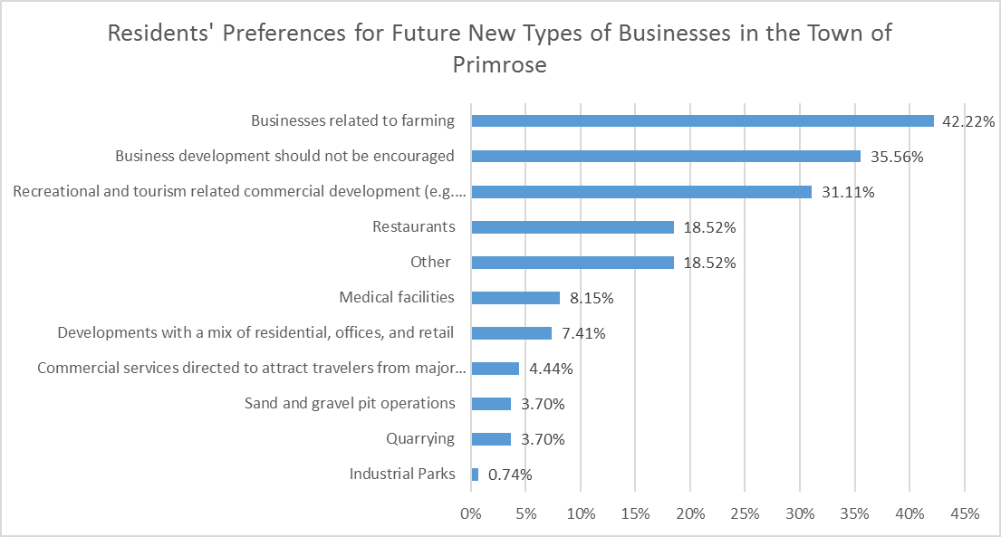

## Strengths and Weaknesses for Economic Development

Town of Dunkirk residents enjoy easy access to the Madison metropolitan area and to the Village of Dunkirk. Transportation networks provide for relatively short commute times. Because of the rural character of much of the town and the lack of historic town commercial centers, careful planning of new commercial development will be necessary to minimize impacts to surrounding properties.

## Economic Development Programs

1. [Tax Increment Financing](http://www.dor.state.wi.us/slf/tif.html) (TIF) is a tool for financing local economic development projects. As outlined in Wis. Act 231, town governments may use TIF to encourage agricultural, forestry, manufacturing, or tourism projects within their jurisdictions.
2. The [Dane County Community Development Block Grant Program](http://www.co.dane.wi.us/plandev/cdbg/index.htm) (CDBG) provides funds for economic development such as business counseling, small business owner education, and loans.
3. The [Community-Based Economic Development Program](http://commerce.wi.gov/CD/CD-bcf-cbed.html) (CBED) provides grants to local governments for incubator projects, economic development plans, and revolving loan programs. Funds are available through an annual application process.

# Goals, Objectives, & Policies

### Goal

Support and contribute to the local and regional economies that sustain our way of life and compliment the Town’s rural character.

### Objectives

1. Allow commercial uses that do not cause environmental degradation or conflict with farming operations or the rural character of the town.
2. Allow business development needed to support existing or new agricultural or passive recreational activities to meet changing market needs.

### Policies

Require new development to establish buffers where deemed appropriate to minimize negative effects on neighboring properties.

Avoid linear strip commercial development.

Commercial development must comply with the siting, lot size, scale, density and operational requirements described in Element 8: Land Use.

Support limited small, home- or farm-based businesses that provide a service to town residents and can supplement town residents’ income.

Agribusiness within the agricultural district will be considered only if:

1. A location in the Town is required to serve Dunkirk farmers,
2. No prime agricultural land is used,
3. Siting and design fits with Dunkirk’s rural character,
4. Natural resources or environmentally sensitive land is not diminished,
5. The quality of existing, adjacent housing stock is maintained, and
6. The goals, objectives, and policies elsewhere in this plan are not undermined.
7. Encourage green building technologies and practices be used in designing, constructing, and maintaining facilities.

Support local, county, state, and federal programs to invest in agriculture, promote innovative products, and create value for farm and related operations.

Support and increase public awareness of alternative agriculture enterprises, such as organic farming, community supported agriculture, and farmer’s markets.

Survey and inventory road conditions and work out conditions with new commercial uses to make sure they pay their fair share of maintenance and repair to town roads caused by heavy vehicle traffic. If necessary, consider seasonal road postings to limit vehicle weights, particularly in spring.

Avoid spending any public funds and incurring any municipal debt for constructing municipal improvements and services associated with commercial and industrial development.

Land development costs shall be the responsibility of the developer.

Require regular review of commercial or business operations permitted under conditional use permits, and consider expiration date on conditional use permits and require operators to reapply after a certain length of time.

Work with University of Wisconsin Extension, local schools, 4-H and other groups to help interested town residents learn new skills.

Continue to work with Dane County, the Capital Area Regional Planning Commission, the Department of Agriculture Trade and Consumer Protection, and the University of Wisconsin to monitor the status and economic health of agricultural and other businesses in the town.

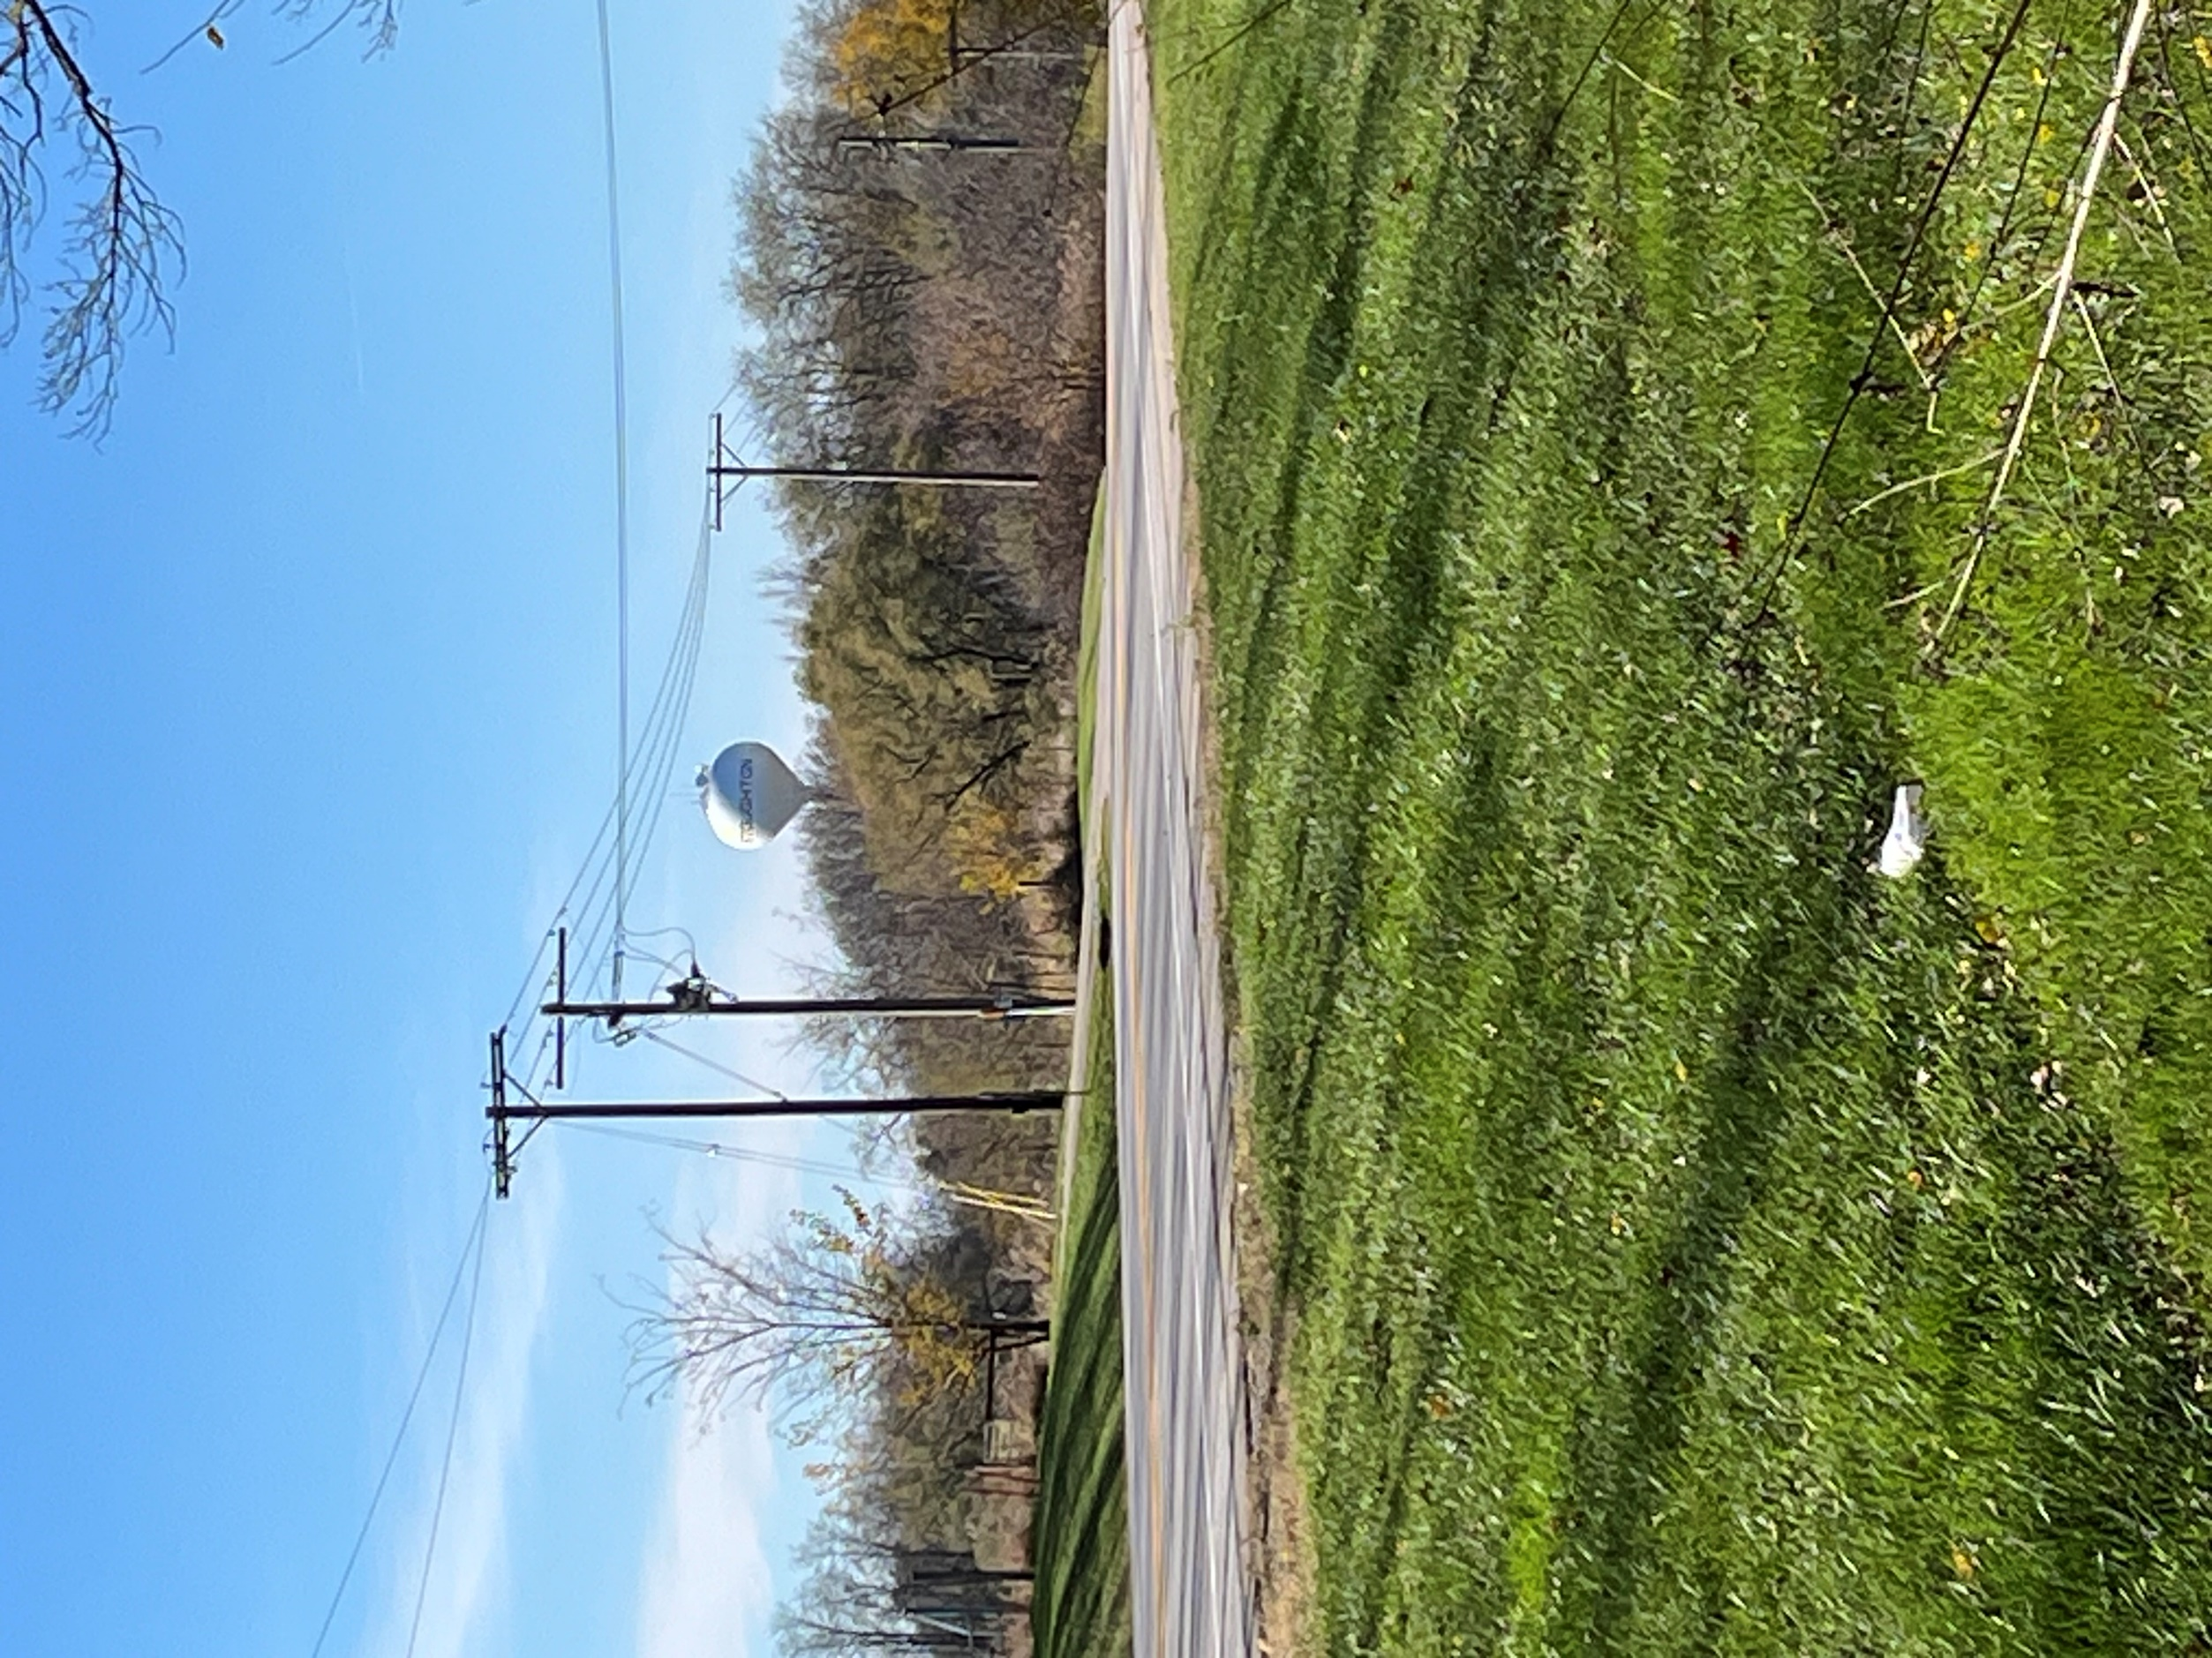element 7:  
intergovernmental Cooperation

# Intergovernmental Cooperation

## Regional Context

### Adjacent Jurisdictions

The Town of Dunkirk shares borders with the Towns of Rutland, Pleasant Springs, and Albion, the City of Stoughton, and the Wisconsin-Illinois border.

### Dane County

The Town of Dunkirk is in County Supervisory Districts 35, near Stoughton, and 37 everywhere else. The Town continues to maintain a good relationship with Dane County departments. The Town relies on the following Dane County ordinances:

1. Dane County Zoning Ordinance,
2. Floodplain Zoning Ordinance,
3. Land Division Ordinance,
4. Subdivision Ordinance,
5. Erosion Control and Stormwater Management Ordinance, and
6. Shoreland/wetland Zoning Ordinance.

### School Districts

The Town is primarily served by the Stoughton Area School District in the north, with a portion in the south east in the Edgerton Area School District.

### Capital Area Regional Planning Commission

The [Capital Area Regional Planning Commission](http://www.capitalarearpc.org) (CARPC) was created in 2007 to serve as the planning and water quality management entity for the Dane County region. CARPC manages Urban Service Areas and delineates environmental and open space corridors. Thirteen Commissioners are appointed by the Mayor of the City of Madison (4), the Dane County Executive (3), the Dane County Cities and Villages Association (3), and the Dane County Towns Association (3).

### Relevant State Agencies

The Wisconsin DNR has regulatory authority over stream crossings and other work in navigable streams and manages Bad Fish Creek Wildlife Area in Rutland just at the Rutland-Dunkirk border. The Wisconsin Department of Transportation manages US Highway 51. The Town also participates in the Department of Agriculture Trade & Consumer Protection’s Farmland Preservation Program.

### Relevant Federal Agencies

The National Park Service and the U.S. Fish and Wildlife Service own lands covering and surrounding Grass Lake in the western portion of the town. Grass Lake Many farmers and other landowners in the town participate in programs funded and operated by the Natural Resource Conservation Service of the U.S. Department of Agriculture.

## Existing or Potential Conflicts with Neighboring Jurisdictions

Adopted comprehensive plans for the City of Stoughton and the Town of Rutland/Albion/Pleasant Springs would both allow for higher densities of nonfarm development than the Town of Dunkirk Comprehensive Plan. The Town of Dunkirk Board and Planning Commission should cooperate with their counterparts in neighboring towns to make sure proposed residential developments across town lines do not negatively impact ongoing farm and conservation activities in Dunkirk.

The adopted comprehensive plans for jurisdictions in neighboring counties do not show any projected expansion into the Town of Dunkirk within the next 20 years (Map 7-1). Consequently, no potential conflicts are anticipated with additional municipalities.

# Goals, Objectives, & Policies

### Goals

1. Facilitate and achieve a high level of intergovernmental cooperation and communication.

### Objectives

1. Maintain good working relationships with adjoining municipalities and other governmental jurisdictions.
2. Explore opportunities for joint planning and cooperation with other towns, villages, cities, Dane County, and state and federal agencies, including intergovernmental land use, service, and boundary agreements.
3. Actively seek opportunities for shared public service agreements that improve services and lower costs.

### Policies

1. Adopt a boundary agreement with Stoughton and jointly develop a detailed development planning process to coordinate growth and protect the interests of town residents.
2. Encourage Stoughton to develop/redevelop its vacant and underutilized land prior to annexation.
3. Seek review and comment from surrounding municipalities on proposed amendments to this plan.
4. Maintain membership on the Commission on Aging.
5. Support the Stoughton Area Senior Center.
6. Actively participate in intergovernmental organizations such as the Dane County Towns Association.
7. Actively participate in formal public hearings, workshops, committees and other outreach opportunities sponsored by other governmental units, including Dane County, the Capital Area Regional Planning Commission, nearby cities and villages, surrounding towns, and state and federal agencies.
8. Provide formal comments on proposed municipal, county, or state plans, regulations, or infrastructure improvements that could affect the Town of Dunkirk.
9. Ensure the Town of Dunkirk Comprehensive Plan is formally adopted as part of the Dane County Comprehensive Plan.

element 8:  
Land Use

# Existing Land Uses

## Agriculture

In 2020, cropland and pasture accounted for 13,696 acres, or 68% of the Town land area, a 1,658 acres decrease since 2000 and another 1,261 since 1990 (note: some of this difference may be from improved measuring for features such as water, which increased 125 acres, or woodlands, which doubled). Conventional farm practices are used to raise corn, soybeans, and cows, other livestock and crops.

## Woodlands

Woodlands account for 7% of the land area and acreage increased 556 acres between 2000 and 2020.

## Residential

The Town maintains a relatively low-density population, with 4.3% of the Town’s land occupied by residential use. Single-family residential is the prevalent housing type. Land devoted to housing increased more than 300 acres since 2000, with 865 acres dedicated to housing in 2020.

## Commercial

Commercial and industrial uses play a very small part (less than 1%) of the Town’s total land use, totaling 21 acres. Three commercial properties, related to landscaping, appliance repair, construction, and salvage are located to the west. WKOW FM Stoughton Radio is also located here.

## Other Public Uses

The predominant public use is transportation infrastructure. Road-right of way-occupies 615.4 acres in the Town. Nearly 70 acres of outdoor recreation serve area residents.

Figure 24: Land Use (acres)

Source: 2020 Dane County Land Use Inventory

Table 5: Land Use by Acreage 1990-20201

| **Acres of Land Use** | **1990** | **2000** | **2010** | **2020** |
| --- | --- | --- | --- | --- |
| Residential | 911.9 | 542.8 | 749.7 | 865.1 |
| Single Family | 466.3 | 542.0 | 747.4 | 773.8 |
| Two Family | 11.9 | 0.8 | 0.4 | 0.4 |
| Multi Family | 12.9 | - | 1.9 | 2 |
| Farm Dwelling | 420.8 | - | - | 88.9 |
| Industrial | 124.0 | 88.2 | 75.2 | 67.5 |
| Manufacturing | 3.8 | 3.5 | 3.9 | 3.8 |
| Wholesale | 4.3 | 1.6 | 2.1 | 2.1 |
| Extractive | 115.9 | 83.2 | 69.2 | 61.6 |
| Transportation | 675.3 | 734.7 | 708.8 | 682.5 |
| Road & Right of Way | 615.3 | 652.4 | 638.4 | 615.4 |
| Railroad | 45.2 | 69.0 | 68.6 | 67.1 |
| Other | 14.8 | 13.4 | 1.8 | - |
| Communication/utilities | 4.2 | 4.1 | 6.8 | 5.6 |
| Generating Processing | - | - | 0.8 | 1.5 |
| Transmission | 2.1 | 2.5 | 4.0 | 2.8 |
| Waste Processing | 1.4 | 1.6 | 2.0 | 1.3 |
| Other | 0.7 | - |  | - |
| Commercial retail | 13.6 | 2.5 | 7.3 | 3.4 |
| General Repair & Maintenance | 8.0 | 2.5 | 7.3 | 3.4 |
| Transportation Related | 3.1 | - | - | - |
| Other | 2.5 | - | - | - |
| Commercial services | 8.0 | 5.2 | 5.2 | 17.5 |
| Lodging | - | 0.2 | - | - |
| Other | 8.0 | 5.0 | 5.2 | 17.5 |
| Institutional/governmental | 17.8 | 13.3 | 13.1 | 13.5 |
| Administrative | - | - | 1.4 | 1.4 |
| Cemetery | 14.0 | 11.4 | 11.7 | 12.1 |
| Other | 3.8 | 1.9 | - | - |
| Outdoor recreation | 99.1 | 44.2 | 67.1 | 67.5 |
| Cropland Pasture | 16,616.8 | 15,355.0 | 13,847.7 | 13,696.5 |
| Woodlands | 727.1 | 845.0 | 1,408.8 | 1,401.2 |
| Vacant Lands | 27 | 47.3 | 26.4 | 36.8 |
| Other Open Lands | 1,656.8 | 2,661.6 | 3,067.1 | 2,848.4 |
| Water | 291.4 | 325 | 399.0 | 416 |
| **Undeveloped Area** | **19,319.1** | **19,233.4** | **18,749.0** | **18,398.9** |
| **Developed Area** | **1,853.9** (9%) | **1,435.0** (7%) | **1,633.2** (8%) | **1,722.6** (8%) |
| **Total Area** | **21,173.0** | **20,668.5** | **20,382.2** | **20,121.5** |

Source: Dane County Planning & Development and CARPC (Land Use Inventory), 2000, 2010, 2020.

1 In 2010 CARPC changed the way agricultural, farm residential and other rural land use were reported. For a more detailed description, see the Farmland Loss Mitigation Report, CARPC, 2010.

# Future Land Use

## Historic Demand

The rate of development is based on number of parcels created each year. Forty-one rezones converted 106 agricultural acres to residential uses occurred between 2015 and 2024 (August). Three zoning permits were issued in 2024 for single family residences. Fourteen rezones occurred in since 2020.

Figure 25: Number of Rezones and Acres Zoned Out of Agricultural Uses

Source: Dane County Planning and Development

## Land Use Projections

Statistics indicate that the limited demand for non-agriculture related residential development will continue to be satisfied by rural densities permitted under Dunkirk’s density policy. Dunkirk is expected is have a declining population. If that projection holds true, land use acreage and distribution will likely remain the same over the next 20 years.

Data show no to minimal change in land use projections for the Town of Dunkirk from 2020 through 2040. Residential land use projections are based on Wisconsin Department of Administration household projections and single-family residential acreage per housing unit as reported in the 2020 Dane County Land Use Inventory. Agricultural, commercial, and other non-residential land uses are based on historic trends between 2000 and 2020.

## Land Use Conflicts

Land use conflicts in the town can arise from residential development that is incompatible with nearby agricultural and open space uses, commercial development that generates excessive traffic, or is incompatible with the Town’s rural character, and/or incompatibilities between town, county and city or village plans. The Town of Dunkirk seeks to minimize such conflicts by:

* limiting density of non-farm residential development in agricultural areas,
* establishing siting and design guidelines,
* limiting commercial activities to those compatible with existing uses,
* redirecting more intensive uses to areas with adequate municipal services, and
* participating in intergovernmental cooperation and planning.

## Redevelopment Opportunities

Approximately 8.5% of the town is developed, so there are limited redevelopment opportunities.

# Goals, Objectives, & Policies

## Land Use Guidance

The following general land use goals, objectives, and policies reflect town desires and are designed to ensure the long-term quality of life respecting the property rights and responsibilities of landowners.

### Goals

1. Create a pattern of development that includes a variety of land uses
2. Prevent conflicts between incompatible uses.
3. Preserve the productive farmlands for continued agricultural use.
4. Protect the natural environment.
5. Maintain the rural character of the town.

### Objectives

1. Protect and maintain public health, safety, and general welfare.
2. Discourage land uses that conflict with agriculture and the town’s rural character.
3. Limit nonfarm development according to density and siting criteria in this plan.
4. Protect, maintain and restore unique natural resources such as wetlands, floodplains, hydric soils, steep slopes, woodlands, and productive farm soils.
5. Maintain and promote eligibility for county, state and federal programs, grants, incentives, cost-share funding and tax credits.
6. Control public costs for roads and services associated with development.

### Policies

1. Provide a sufficient supply and mix of land uses that can be served by town and Stoughton services.
2. Rezoning proposals shall be consistent with this plan.
3. Land development costs shall be the responsibility of the developer.
4. Community facilities (libraries, post offices, schools, etc.) should be located in or near Stoughton.
5. Follow the policies of this Plan when making land use decisions.
6. Avoid linear strip commercial development.
7. Promote compact development patterns in residential and commercial areas.
8. Preserve lands identified as environmental corridors.
9. Use land use tools to create a distinct open space corridor between the town and surrounding communities.
10. Encourage green building practices in designing, constructing, and maintaining homes, accessory buildings, businesses, and facilities.
11. Require new development to establish buffers, where deemed appropriate, to minimize potential negative effects to neighboring properties.
12. Ensure cellular towers installation is consistent with Dane County’s ordinance regarding the procedure and standards for the placement, construction, and modification.
13. Monitor Stoughton’s and surrounding towns’ land use plans.
14. Direct high-density residential, commercial, and industrial development to lands in or adjacent to Urban Service Area where public sewer is available or planned.
15. Require recreational development to submit a site plan as part of a development proposal. If the town road requires improvements, the applicant will be required to pay for his/her share of such improvements.
16. Limit non-farm residential development to those areas that are not classified as productive farmland.
17. Require agencies and bodies responsible for the location of public improvements such as roadway corridors, pipelines, or power lines to recognize and comply with the land use goals, objectives, and policies of the Town.
18. Promote state and localprograms that encourage farming, or investment in farming, within the Town.
19. Use parks and open space to buffer incompatible land uses, protect environmentally sensitive lands, and complement other land development.
20. Implement alimited transfer of development rights program as follows:
    1. Development rights can be transfer between contiguous or non-contiguous farm units under single ownership as of August 22, 2000.
    2. The proposed transferring parcel must have a split available under the town's density policy. The density of the proposed receiving parcel must not exceed four dwelling units with minimum lot sizes of one acre and maximum lot sizes of five acres. Contiguous lots are encouraged.
    3. The requesting landowner(s) must obtain a density analysis from the Dane County Department of Planning and Development for both parcels.
    4. The proposed receiving parcel must meet Dane County and Dunkirk development siting criteria for road frontage and a buildable site.
    5. At the time of limited transfer, a site plan for each receiving lot must be approved by the Dunkirk Plan Commission and the Dunkirk Town Board.
    6. Deed restrictions prohibiting development are required for parcels that reach the density policy limitation. Deed restrictions or notice documents may also be required for other parcels not directly involved in the transfer with the same owner as of August 22, 2000. Applicants must provide legal descriptions of the parcels to be deed restricted and/or noticed.
    7. Single ownership is defined as parcels owned by one individual or by a married couple, partnership, or corporation including that individual.
    8. The receiving parcel soils must be suitable for residential development.
    9. The receiving parcel must not be comprised entirely of Class I soils (as Defined by the Dane County Soil Survey). Exceptions may be made for parcels of equal productivity, such that the receiving parcel is preferable for residential purposes.
    10. The soils of the transferring parcel must be Class I or II (as defined by the Dane County Soil Survey).
    11. The receiving parcel must have adequate road access and a suitable building site that would not result in a "flag lot" with a long driveway crossing agricultural land.
    12. The proposed transfer must not conflict with existing uses on adjacent properties.
21. Implement land use regulation using three districts: Farmland Preservation, Environmental & Resource Protection, and Public Lands (see Planned Land Use Maps 8-3, 8-4).

## Land Use District Regulations

Policy Summary

* Density Details:1 unit:40 acres
* Farmland Preservation date: 7/1/1979
* Rounding: No
* Senior Planner: Majid Allan
* Adopted:8/3/2006; ?/?/2024
* Key policies:
* Lot size requirements:
* Density policy (in brief):
* Does existing dwelling count against density: Yes
* Density policy for ADUs (detached & attached):
* Hillside/Slope/Hilltop protection policies:
* Prime ag soil protection policies: Yes
* Commercial use policies:
* Other key policies to note:

The above goals, objectives, and policies are implemented through the districts named in Land Use Policy 8. Each district has unique development standards as detailed and mapped in this section.

The Future Land Use Map is intended to illustrate and guide the future growth and development of Dunkirk over the next 20 years and beyond. The map serves as a guide for the Plan Commission and Town Board when making land use, zoning, and infrastructure decisions. The map provides direction for private sector property owners and developers when making decisions about using their properties within the town.

### Farmland Preservation Area

The Town established the Farmland Preservation Area to preserve agricultural lands and rural character while providing opportunities for compatible development. This designation aims to promote investment in agricultural operations by ensuring that incompatible land uses are directed to areas that minimize interference with farming activities. This district encompasses the most land within the town and includes productive farmlands, other agricultural land uses, pastureland, woodlots, and residences and out-buildings.

Appropriate Zoning Designations  
Farmland Preservation Area

* FP-35 Farmland Preservation
* FP-1 Farmland Preservation
* FP-B Farmland Preservation-Business
* NR-C Natural Resource Conservation
* RE Recreational
* RR-1, 2, 4, 8, 16 Rural Residential
* RM-16 Rural Mixed Use zoning existing prior to March 1, 2024
* LC Limited Commercial

#### Development Density Policy

The density policy limits the amount of non-farm development and is used to guide decision-making when considering rezones out of the A1-Ex zone. Density limitations apply to:

* + residential dwellings,
  + non-farm commercial development initiated after August 3, 2006 (adoption date of the Town’s first comprehensive plan), and
  + land or easements to public entities unless otherwise indicated in sales contracts, deeds, or recorded agreements.

Under the adoption of the Town of Dunkirk Comprehensive Plan the number of densities for non-farm development (referred to herein as, “split” or “density unit”) on a parcel of land are based on the number of contiguous acres held in single ownership as of July 1, 1979. Density units are not equivalent to or guarantees of future building sites.

Building site criteria for a proposed nonfarm development must be met before a density unit may be used.

1. Contiguity is maintained across public rights-of-way and navigable waters. All land, including ponds, wetlands, floodplains, and environmental corridors, will be counted to determine acreage.
2. Single ownership is defined as parcels owned by one individual, a married couple, partnership, or corporation including that individual.
3. Gross acreage used for the calculation includes roads and other public rights-of-way, will be used to determine farm unit size.
4. Any existing residence, regardless when residence was constructed, counts as one split. An existing residence may be replaced and not counted as a split if the residence is removed, or its owners can prove it has physically converted to a nonresidential use.
5. Acreage will not be rounded up to meet the minimum requirement. The 1979 Land Atlas and Plat Book for Dane County guide ownership and acreage determinations.
6. Farm units with a portion of the land annexed to the city, will have splits deducted equal to the number of residences constructed on the annexed property. If the annexed property is undeveloped, the acreage on the annexed property will be deducted from the farm unit total when determining splits.
7. A density analysis by the Dane County Department of Planning & Development may be required prior to town consideration of split requests.
8. When the splits on a farm unit are exhausted, the town shall require that a deed restriction be recorded to prohibit further residential development on that unit.

#### Site Plan Review: Development Standards & Criteria

The Town Planning Commission and Board must approve a site plan for all proposed non-farm rezones or development, land divisions under county and town land division ordinances, and building sites under the town building permit ordinance within the Agricultural Preservation Area. Site plans must, in the opinion of the Town Planning Commission and Board:

1. Show the proposed layout, building location and use, parking area(s), significant natural features, existing and proposed vegetation, and driveway access.
2. Meet all standards of section 10.101(6), Dane County Code.
3. Minimize the break-up of contiguous tracts of agricultural land, woodlands or environmentally sensitive land with the least impact on the surrounding resources.
4. Not be located on historically cropped lands, unless exempted by the Farmers Retirement house provision under “Other Development Considerations” below.
5. Must comply with Resource Protection Corridor policies.
6. Minimize the destruction of hardwood trees and environmentally sensitive/important areas. Short driveways and building near the edge of woods may be required. No more than 30% or two (2) acres, whichever is less, of existing woodlands on a lot may be cut for the building site and driveway.
7. Be compatible with the rural character of the town using the following criteria:
8. Site and design buildings to minimize visual impact when viewed from existing houses and public roads. Hide buildings so that are not visible from Town roads where possible.
9. Roof lines cannot extend above the hilltop or ridge line, if possible, on properties with hilltops or ridges to minimize visibility from the road and from neighboring properties.
10. Natural vegetation should be left in place to screen new buildings. Where natural vegetation is not present, screening by plantings, berms, or other features may be required to mitigate the visual impact of residential development.
11. Minimize conflict with neighbors. New driveways, houses or outbuildings will be located a minimum of 500 feet from neighboring out-buildings and residences, unless the adjacent residence is also the property of the person proposing the new building and is part of a planned “cluster development.” Buildings and driveways must be 100’ from proposed or existing property lines. At the discretion of the Town Board and Planning Commission, exceptions to this rule may be permitted under the following circumstances:
    * 1. enforcement of the rule is impossible because the parcel is too small;
      2. placement of the new driveway in accordance with the rule would disturb important agricultural or natural resources, or,
      3. the adjoining landowner has no objection to the structure being placed close to his or her property than the rule would require.
12. Be a minimum parcel of two (2) acres, if not in a woodland.
13. Nonfarm zoning parcels shall be the minimum size necessary to accommodate the proposed use and meet the town driveway standards, minimum road frontage and other criteria of the town comprehensive plan.
14. Be a minimum parcel of ten (10) acres if in a woodland area greater than 20 contiguous acres existing as of 1981. Development is restricted to one (1) residential build.
15. Be in compliance with the Town Driveway Ordinance, County, and/or State Highway access requirements, such that driveways and roads are the minimum length necessary to access the site, accommodate emergency vehicle access, and are constructed using erosion control measures and surrounding lands are returned to a near normal setting after completion. As a condition of approval, Driveways longer than 125 feet in length, require proof of compliance with county erosion control and stormwater regulations. For driveways 125 feet in length or shorter, the Town may require:
    * 1. an erosion control plan, and/or
      2. stormwater management plan, or
      3. a preliminary review letter meeting county ordinance standards.

#### Other Development Considerations

##### Split Allocation to Land transferred after April 28, 1981

Land sales of more than 35 acres occurring after April 28, 1981 do not result in new allotments of density units. When land sales of more than 35 acres occur after April 28, 1981 without clear documentation or recorded agreement between buyer and seller, or subsequent/current owners, regarding any transfer of splits or density units, the Town shall use the following guidelines when considering allocating a density unit(s):

1. Landowners are encouraged to document that a density unit is being transferred or retained when selling tracts of land more than 40 acres. The Town may request these records for development or rezone petitions. Supporting documents may include, but are not limited to, sales contracts, warranty deeds, affidavits, and written agreements.
2. Landowners needing to combine portions of different April 28, 1981 farm parcels to meet the 35 acre minimum are not entitled to a nonfarm density unit.
3. In the absence of documentation, splits will be allocated on a proportional basis to the current owners of the April 28, 1981 farm unit. Under no circumstances shall the density standard be exceeded on the April 28, 1981 farm parcel.
4. Vacant, legal, substandard (sometimes referred to as “non-conforming”) FP-1 zoned parcels less than 35 acres in size in existence since April 28, 1981 may be permitted to rezone to an appropriate district to allow for one single-family home, providing siting criteria are met. Such parcels may not be further divided
5. Illegally created substandard parcels with an existing residence may be permitted to rezone to an appropriate district to bring the parcel into compliance, provided the parcel complies with all density and siting criteria of this plan. Substandard, legally created FP-1 zoned parcels under 35-acre parcels, with an existing residence, may not be further divided.
6. Illegally created substandard parcels are not permitted to split.

##### Duplexes

Zoning for new duplex or two-family homes or for the conversion of existing large houses to duplex use will be considered if the following criteria are met:

1. Any existing house must have a total floor area of at least 1,800 square feet.
2. The Public Health agency of Madison and Dane County confirms that the private onsite wastewater treatment system is adequately sized, installed, and maintained to accommodate duplex use.

The duplex structure will count as two density units under the density limitation. “Dependency living arrangements,” as defined in ss. 10.01(19a) & (19b), Dane County Code, and allowed under a conditional use permit, are not considered a duplex under this policy and do not count as an additional density unit.

##### Commercial Development

The Town shall implement the following policies regarding new, or expansion of existing, commercial development within an Agricultural Preservation Area:

1. Allow limited commercial development, under the Limited Commercial zoning criteria, or as conditional uses, needed to support existing agricultural activities, provide supplemental income for farm families, or provide agricultural-related services.
2. Development must not result in environmental degradation, inappropriate traffic volumes, or conflict with farming activities.
3. Limit rezoning to the portion of land necessary for the proposed commercial use.
4. The applicant must request a specific commercial use when requesting a rezone.
5. The Town may require a condition on the rezoning to limit activity to the specific use designated on an approved site plan.
6. All non-farm commercial, but not all non-farm limited commercial, use shall count against the town density policy.
7. Avoid substantial public expenditure and/or incurring municipal debt for provision of municipal improvements and services associated with commercial development.

##### Mineral Extraction

The town will consider Conditional Use Permits for new or expanded mineral extraction operations the Agricultural Preservation District that:

1. are consistent with the goals and objectives of this Comprehensive Plan,
2. are consistent with agricultural use and farmland preservation, and
3. adequately protect public safety, rural character, and the environment.

The town will work with owners of former extraction sites, neighbors, and the Dane County Zoning Division to encourage clean-up and reclamation. Proposed land uses after reclamation must be consistent with the Town of Dunkirk Comprehensive Plan and density policies.

Applicants must contact the town Plan Commission secretary to have the proposal placed on the agenda of the next available Plan Commission meeting and meet with the town Plan Commission prior to filing a Dane County conditional use permit (CUP) application.

1. At least two weeks prior to the scheduled Plan Commission meeting, applicants should complete and provide to the town Plan Commission secretary and the Town Clerk the following documents (see Appendix 2 for application materials):
   1. Completed application materials, including site plans and reclamation plans, required by the Dane County Department of Planning and Development for a mineral extraction CUP, and
   2. The Town of Dunkirk Mineral Extraction Questionnaire.
2. Prior to the scheduled Plan Commission meeting, applicants should review and understand the list of standard conditions for mineral extraction CUPs provided by the Dane County Department of Planning and Development, as well as the reclamation standards required under Chapter 74, Dane County Code.
3. After the applicant files a conditional use permit with Dane County, the Plan Commission may recommend conditions to the town board based on the Mineral Extraction Questionnaire, county standard conditions, and public input received.
4. At its discretion, the Plan Commission may choose to delay making a recommendation to the town board until after the county public hearing.

##### Renewable Energy Facilities

The Dane County Zoning Ordinance describes three renewable energy facilities categories:

1. Small-scale facilities, such as rooftop solar panels or wind turbines intended primarily for onsite use. Such services are a permitted use in every zoning district.
2. Mid-size facilities intended primarily for offsite use, but not under the direct approval authority of the Wisconsin Public Service Commission. Such uses are a conditional use in several county zoning districts.
3. Large-scale facilities intended primarily for offsite use, and under Wisconsin PSC authority. Such facilities are exempt from county zoning.

The Town will apply the following policies to Conditional Use Permits for renewable energy facilities, and will advise the Public Service Commission to follow these policies when issuing permits within the Town of Dunkirk:

1. Minimize the need for new electrical transmission lines; locate new renewable energy installations as close as possible to existing transmission facilities.
2. Where practical, manage utility-scale installations density and size to minimize impacts to adjoining agricultural and rural character.
3. Except where required for aviation or other safety concerns, encourage setbacks, vegetative screening, berms, or other practices to minimize visual impact.
4. Encourage multiple-use facilities that allow agricultural, natural resources, habitat and/or soil and water conservation uses to coexist with energy generation.
5. Arrange energy infrastructure, fencing, and berms to allow for equipment movement, habitat, wildlife corridors, and pervious cover to minimize runoff.
6. Ensure installations comply with county erosion control and stormwater standards during construction, operation, maintenance, and decommission.
7. Encourage adaptive use of operating or closed mineral extraction or other rural industrial sites for renewable energy use.
8. To the extent possible, avoid productive farm soils.
9. Make sure landscaping and other vegetation is maintained to continue to serve its intended purpose and does not create sources for invasive species.
10. Require decommissioning plans with financial instruments sufficient to cover equipment removal and reclamation. Lands should be returned to a use described in this plan.

#### Natural Resource Based Districts

##### Resource Protection Corridors

Appropriate Zoning Designations  
Environmental &Resource Protection District

* NR-C Natural Resource Conservancy
* FP-35 Farmland Preservation
* FP-1 Farmland Preservation
* RE Recreational

The Town established Resource Protection Corridors, as shown on the Planned Land Use Map 8-3, to preserve and enhance natural resources by limiting development and promoting best practices in management and restoration. This district applies to:

1. 100-year floodplains,
2. wetlands,
3. hydric soils,
4. Groups I & II Farm Soils under the Dane County Land Evaluation and Site Assessment classification (LESA), and;
5. steep slopes exceeding 25% grade.
6. Oak Savannahs

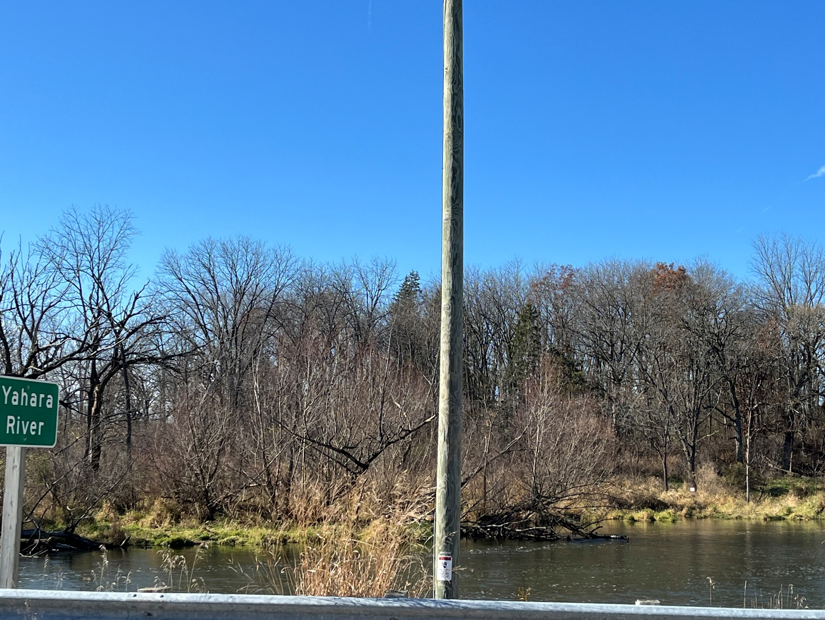Non-farm development within the Resource Protection Corridor is prohibited, except as provided below. The town shall use the following policies in this district:

1. Maintain land in this district as agricultural, conservation, or open space use.
2. Require erosion control and soil and water conservation practices for all land-disturbing activities.
3. Prohibit new structures, buildings, or other development, and limit impervious surfaces.
4. Provided all applicable county and state erosion control, stormwater, shoreland, wetland, floodplain, and stream crossing regulations are met, the following may be permitted in the Environmental & Resources Protection District:
5. Expanding or improving existing accesses or driveways to meet Town driveway standards.
6. Agricultural structure replacement, if no other site outside the Natural Resources Protection District is practical and construction, is limited to the footprint of the original structure.
7. Support programs to restore natural vegetation, remove invasive species, and improve habitat.
8. Where there are disputes over mapped wetlands, floodplains, or onsite soil conditions, the Town Plan Commission and Board may refer to studies derived from onsite field conditions to determine Resource Protection Corridor boundaries. Any such study must be approved by the Wisconsin Department of Natural Resources, the Federal Emergency Management Agency, the Dane County Zoning Administrator, and/or the Dane County Land Conservation Division, as a condition of approval. Developers bear the burden of proof that mapped Resource Protection Corridors are in error.

#### Public Lands District

The Town established the Public Lands District to coordinate with the public and nonprofit entities that own land in the town. The Wisconsin Department of Natural Resources own property off Taylor Lane. The federal government owns property adjacent to Grass Lake.

The Town shall use the following policies in this direct:

1. Work with the agencies that own land in the Town to develop agreements on future uses for the lands.
2. Participate in the Dane County Parks and Open Space Plan updates, and relevant state and federal programs.
3. Develop procedures for adequate citizen input and analysis against the goals, objectives, and policies of this Plan related to land use decisions, acquisitions, or dispensations of public lands.

Appropriate Zoning Designations  
Public Lands District

* NR-C Conservancy
* FP-35 Farmland Preservation
* FP-1 Farmland Preservation
* RE-1 Recreational

1. Encourage land uses that are compatible with natural resource preservation and protection.
2. Encourage recreation on publicly owned lands for Town residents.
3. **Commercial District**

Identifies a small area of existing town commercial development along U.S. Highway 51 and includes some properties on Hoel Avenue.

1. **Park/Open Space District**

Designates an existing undeveloped parcel along U.S. Highway 51 and Velkommen Way for development of a trail connection between the Stoughton Virgin Lake trail and an existing greenway to the north.

1. **Conservancy District**

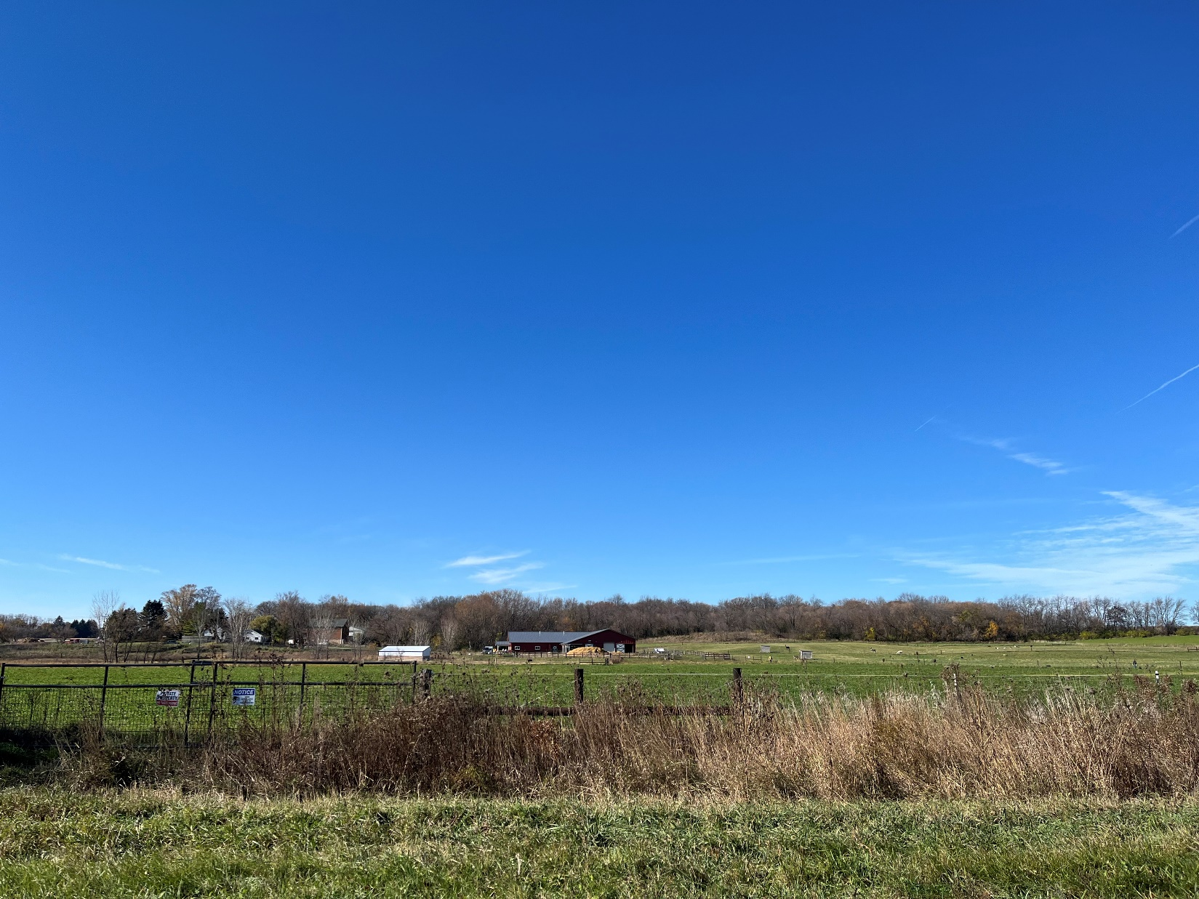Designates a lowland area extending from County Road N Eastward beyond Spring Road.

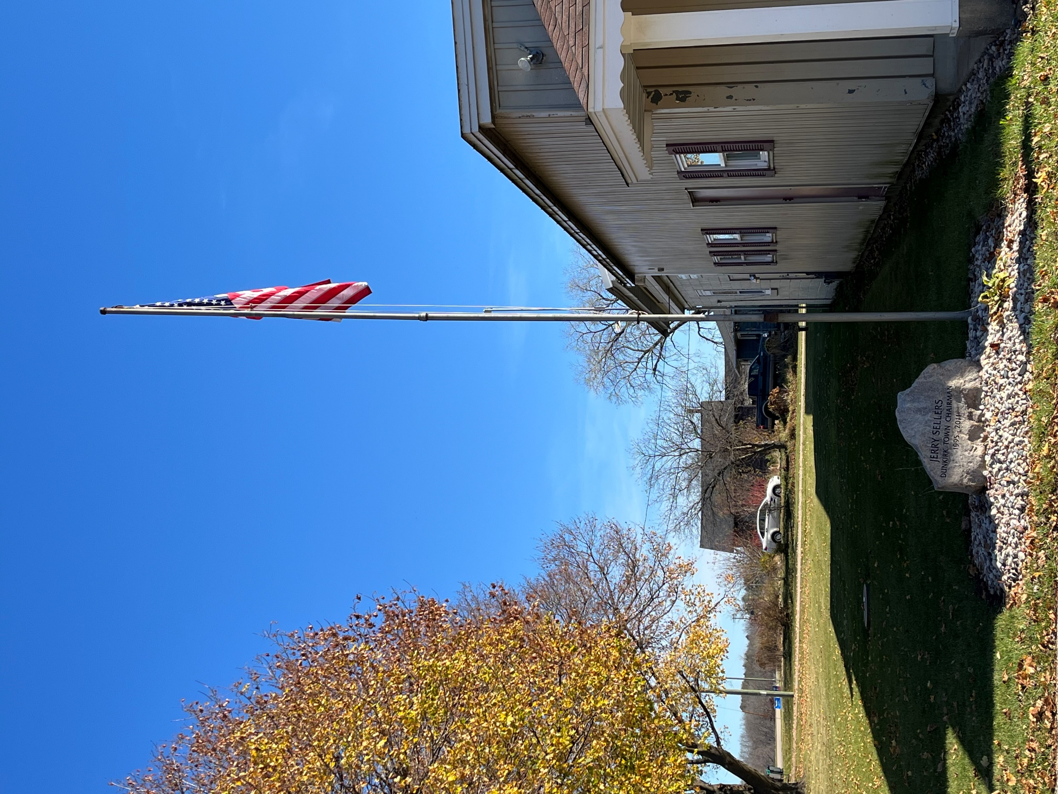element 9:  
Implementation

# Regulatory Tools

The Town of Dunkirk regulates land use through the following mechanisms:

## Town of Dunkirk Driveway Ordinance

This ordinance regulates the creation, reworking or expansion of roads that ultimately connect to a public right-of-way. Applications for any driveway permit must comply with all of the provisions of this ordinance and must be consistent with the *Town of Dunkirk Comprehensive Plan*.

## Town of Dunkirk Building Permit Ordinance

This ordinance regulates the placement of residential and residential accessory buildings on land in the Town of Dunkirk. Building sites must comply with the requirements of the ordinance and with the *Town of Dunkirk Comprehensive Plan.*

## Zoning Ordinance- Chapter 10, Dane County Code

Through zoning maps and text, the ordinance governs the use of publicly and privately owned land in the town. The town will not recommend approval of rezone petitions under s. 59.69(5)(e), Wis. Stats., or on Conditional Use Permits under s.10101(7), Dane County Code, unless they are consistent with the *Town of Dunkirk Comprehensive Plan.*

## Land Division Ordinance- Chapter 75, Dane County Code

The town falls under the Dane County subdivision ordinance (Chapter 75 of the Dane County Code of Ordinances) which outlines provisions for subdividing parcels of land into smaller parcels. This ordinance applies to any division of land that creates a parcel of 35 acres or less in size. Approval of any plat or certified survey maps will require full compliance with the Ordinance and with the *Town of Dunkirk Comprehensive Plan.*

## Erosion Control and Stormwater Management Ordinance- Chapter 14, Dane County Code

To ensure environmental protection of natural resources and features, the town has adopted the Dane County ordinance.

## Shoreland Zoning Ordinance- Chapter 11, Dane County Code

Dane County administers this ordinance to regulate development within 1,000 feet of a lake and within 300 feet of a stream to protect water quality, fish and wildlife habitat and natural scenic beauty.

## Floodplain Zoning Ordinance- Chapter 17, Dane County Code

Dane County administers this ordinance to control development within floodplains to reduce flood hazards and protect the environment.

## Sign Regulations

Sign regulations are contained within the Dane County Zoning Ordinance, Chapter 10 of the Dane County Code of Ordinances (DCCO).

## Building and Mechanical Codes

The town falls under the state Uniform Dwelling Code (UDC).

## Rural Density Policy

The town’s rural density policy limits the number of lots that may be created by certified survey to one parcel for each 35 acres, or portion thereof, owned as of December 15, 1994. To prevent the occurrence of multiple divisions by successive landowners, this limitation runs with the land; is cumulative; and applies to those persons owning land within the town on April 28, 1981, and to their grantees, heirs, successors and assigns. For further details, please refer to the Land Use policies found in Chapter 8.

## Sanitary Codes

The town is covered by the Dane County Private Sewage System Ordinance and Health Ordinance (Chapter 46 of the DCCO).

# Adoption, Evaluation, Amendments & Updates

Following the requirements of Wisconsin’s comprehensive planning legislation, the Town Board adopted the *Town of Dunkirk Comprehensive Plan* by ordinance after receiving recommendation from the Town’s Plan Commission and holding a formal public hearing. In addition, the *Town of Dunkirk Comprehensive Plan* was approved by the Dane County Board of Supervisors as part of the *Dane County Comprehensive Plan.*

In accordance with the State’s comprehensive planning law, each element of the *Town of Dunkirk Comprehensive Plan* is integrated and consistent with the other elements. Elements are prepared to collectively achieve the Town of Dunkirk’s vision and goals.

Ongoing evaluation of the *Town of Dunkirk Comprehensive Plan* will occur while being utilized by the town. Progress toward goals will be reported, and changes in conditions that affect elements of the plan will be noted. When changing conditions in the town warrant minor modification of the *Town of Dunkirk Comprehensive Plan* text or maps, an amendment shall be made. Reasons for an amendment may include:

* Changes in state or federal law(s) affecting comprehensive planning,
* Changes to goals, objectives, policies, or recommendations in the *Town of Dunkirk Comprehensive Plan*,
* Changes in community demographics, and/or
* Instances where the *Town of Dunkirk Comprehensive Plan* becomes inconsistent with other policy goals.

The Town Board and Plan Commission will review the *Town of Dunkirk Comprehensive Plan* every year*,* to see if amendments or updates are necessary. At least every five years, the Plan Commission will recommend, if needed, minor updates or amendments. At least every ten years, the town will perform a major update of the *Town of Dunkirk Comprehensive Plan*, in accordance with State law. Different than an amendment, an update may accommodate significant changes and modifications to plan text and maps.

### A. Goals

Encourage residents to be involved in community activities.

Keep this comprehensive plan relevant, useable, timely, and accessible.

### B. Objectives

Increase citizen involvement and interest in town government.

Regularly update the plan.

### C. Policies

1. Recruit and benefit from the skills and expertise of residents by getting them involved in local government.
2. Encourage residents to vote.
3. Encourage residents to review draft plans, propose plan amendments, and participate in the development of rules and regulations.
4. Town employees and officials will promptly respond to citizen inquiries and requests.
5. Innovative ways of doing business will be supported that foster efficiency, communication with residents, and open government.
6. Encourage the development of a Dunkirk trust.

# Implementation Timeline

A timetable in Table 6 was created to facilitate monitoring and evaluate progress. As is evident from the table, most of the activities are, and will continue to be, ongoing.

Table 6: Implementation Timeframe

|  |  |  |  |  |  |
| --- | --- | --- | --- | --- | --- |
| **Housing** | **2025-30** | **2031-35** | **2036-40** | **Ongoing** | **Entity** |
| 1. Review the town’s/county’s land development regulations to ensure that policies are implemented. |  |  |  |  | Plan Commission |
| 1. Develop and maintain an accounting of splits. |  |  |  |  | Town Board |
| 1. Follow the residential density policy in this Plan. |  |  |  |  |  |
| 1. Identify need and interest in CDBG program. |  |  |  |  |  |
|  | | | | | |
| 1. Adopt and use an official map to identify existing and planned transportation facilities. |  |  |  |  | Town Board |
| 1. Conduct an annual review of town roads using the PASER and use the results to develop a work program to improve them. |  |  |  |  | Road Supervisor |
| 1. Write and send letter to the rail operator. |  |  |  |  | Town Board |
| 1. Make recommendations to the county and State DOT regarding bike lanes on state and county roads. |  |  |  |  | Town Board |
| 1. Review zoning and future land use maps to ensure development provides for pedestrian transportation. |  |  |  |  | Plan Commission |
| 1. Work with adjacent municipalities to extend bike and pedestrian trails into the town. |  |  |  |  | Plan Commission |
| **Economic Development** | | | | | |
| * + - 1. Allow limited commercial uses appropriate to a rural town, consistent with land use policies in Element 8: Land Use. |  |  |  |  |  |
| **Utilities and Community Facilities** | | | | | |
| 1. Work with Stoughton to develop stormwater management regulations for new and existing development. |  |  |  |  | Town Board |
| 1. Plan and budget for needed town stormwater projects. |  |  |  |  | Town Board |
| 1. Periodically include information in the town’s newsletter about waste reduction, recycling, and proper disposal methods for household hazardous waste. |  |  |  |  | Town Board |
| 1. Work with Dane County to develop policies and guidelines for wind turbines, communication towers, and manure management. |  |  |  |  |  |
| Intergovernmental Cooperation | | | | | |
| 1. Share information with neighboring jurisdictions as comprehensive plans are updated or amended. |  |  |  |  |  |
| Agricultural, National, and Cultural Resources | | | | | |
| 1. Follow the residential density policy in the Farmland Preservation District. |  |  |  |  |  |
| 1. Continue to implement the driveway ordinance. |  |  |  |  |  |
| 1. Work with the county to explore programs to preserve farmland (purchase/transfer of development rights). |  |  |  |  |  |
| Land Use | | | | | |
| 1. Follow the Town of Dunkirk Comprehensive Plan recommendations when considering zoning petitions and land divisions. |  |  |  |  |  |